My Family Health Portrait
Evaluation Activities from Oct. 2004 – Apr. 2006

Prepared for: | Larry Thompson  Chief, Communications and Public Liaison Branch  Office of Policy, Communications and Education  Office of the Director  National Human Genome Research Institute
Prepared by: | Lynn Baumeister  Cirque Interactive LLC  301-351-7431  lynn@cirqueinteracive.com  Completed: June 2006
Funded by: | NIH Evaluation Set-Aside Program  PIC #04-130

Client Tool – Launched November 2004 |  | Web Version – Launched November 2005
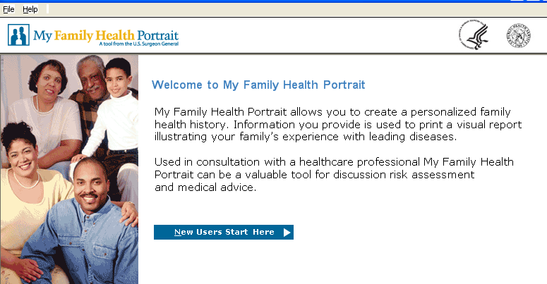 |  | 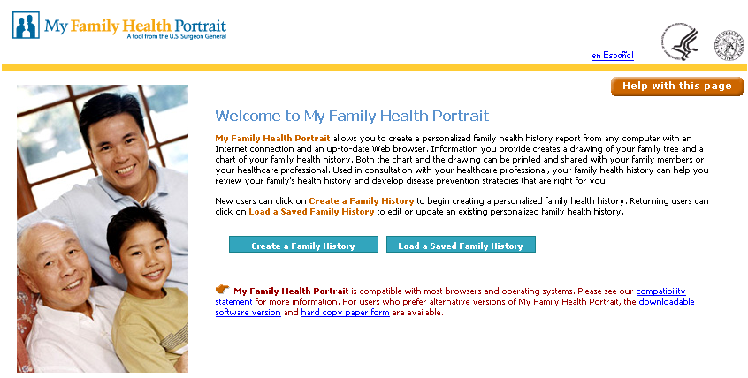

Overview 3
Client Tool 3
Pre-launch Evaluation Activities 3
Post-launch Evaluation Activities 3
Web Version 3
Pre-launch Evaluation Activities 3
Post-launch Evaluation Activities 3
Summary 3
Appendix A: Usability Testing (client tool) 3
Findings and Recommendations 3
High Priority Findings and Recommendations 3
Medium Priority Findings and Recommendations 3
Low Priority Findings and Recommendations 3
Download Process - Findings & Recommendations (High Priority) 3
Recommendations for Install Process 3
Appendix B: Sect. 508 Compliance (client tool) 3
Section 508 Findings and Recommendations 3
High Priority Findings and Recommendations 3
Medium Priority Findings and Recommendations 3
Low Priority Findings and Recommendations 3
Appendix C: Survey for client tool 3
Survey Questions 3
Survey Results 3
Appendix D: Usability Testing & 508-compliance Assessment (web version) 3
Findings and Recommendations: Usability Testing with Stakeholders 3
Findings and Recommendations: Iterative Usability Testing with Representative End-users and Sect. 508-compliance Assessment (web version) 3
Iterative Usability & Sect. 508-compliance Testing Results10/06/05 3
Iterative Usability & Sect. 508-compliance Testing Results10/13/05 3
Iterative Usability & Sect. 508-compliance Testing Results10/20/05 3
Iterative Usability & Sect. 508-compliance Testing Results10/27/05 3
Iterative Usability & Sect. 508-compliance Testing Results11/01/05 3
Iterative Usability & Sect. 508-compliance Testing Results11/08/05 3
Appendix E: Survey for web tool 3
Survey Questions 3
Survey Results 3
Appendix F: Materials for MFHP strategy mtg. 4/6/06 3
Agenda 3
Presentation Slides 3
Support Material for Discussion on Future MFHP Functionality 3
Support Material for Discussion on Incorporating Video 3

Overview
This report describes evaluation activities on My Family Health Portrait (MFHP), a tool to assist people in recording their family health history. MFHP is a key element of the Surgeon General’s National Family History Initiative which is now an annual event celebrated on Thanksgiving Day. MFHP was launched under the auspices of the US Surgeon General’s Office but was conceived and developed by the Communications and Public Liaison Branch (CPLB) of the National Human Genome Research Institute (NHGRI).
Since its inception, MFHP has undergone two major releases: a client tool that runs on PCs using the Windows operating system, and a newer web-based version. The client tool was launched in November 2004 prior to the first National Family History Day. The newer web-based version was released a year later in November 2005 prior to the second National Family History Day.
This report summarizes evaluation activities on MFHP between October 2004 and April 2006. The table below shows the timeline of evaluation activities on MFHP during that time.
Time line of MFHP evaluation activities

Client tool
Oct 2004 | Pre-launch | Usability testing with pre-launch beta version of client tool
Oct 2004 | Pre-launch | 508-compliance testing
Nov 2004 | Launch | Launch of client tool
May 2005 | Post-launch | Survey posted to collect feedback

Web version
Jun – Jul 2005 | Pre-launch | Usability testing with key stakeholders on prototype
Oct 2005 | Pre-launch | Usability testing with representative end-users
Oct 2005 | Pre-launch | 508-compliance testing
Nov 2005 | Launch | Launch of web-based version
Feb 2006 | Post-launch | Survey posted to collect feedback
Apr 2006 | Post-launch | Summary of feedback data presented to decision-making team from NHGRI’s CPLB.

This remainder of this report summarizes each of the evaluation activities shown in the table above with full details being provided in the appendices.

Client Tool
In the fall of 2004, the NHGRI commissioned an external contractor to build a client tool for MFHP. The client tool was built using the Microsoft .NET Framework which restricted it to PC’s running up-to-date versions of the Windows operating system. Despite these restrictions it was a successful venture. More than 120,000 copies were downloaded between October 2004 and November 2005.

Pre-launch Evaluation Activities
In October 2004, before the client tool was publicly launched, there were two rounds of evaluation conducted on it. The first evaluation was usability testing with representative end-users. This testing was done with a pre-release beta version of the application. Because the time-line for development and deployment of the client tool was highly compressed, there was only time to test with three participants. The participants were observed while they used MFHP to enter their family health history. And although this usability testing did not include a large number of participants, it was nonetheless very useful. Observations of the participants revealed common areas of difficulty and the development team was able to address some of them despite the tight time-line. A summary of the results from this round of usability testing is in Appendix A.
The second evaluation was to ensure that the client tool for MFHP was section 508 compliant. Section 508-compliance testing was done by listening to the pages using a screen reader and then relaying areas of difficulty to the external contractor responsible for building the tool. A summary of the results from this round of 508-compliance testing is in Appendix B.

Post-launch Evaluation Activities
In late May 2005, a survey was posted to collect information to help the NHGRI CPLB make informed decisions about the next version of MFHP. The survey requested information in these areas:
- Where respondents heard about MFHP
- Respondent’s expected use of the family health history report produced by MFHP
- Download and installation difficulties
- What aspects of MFHP respondents found helpful
- What aspects of MFHP respondents found limiting
- Limited demographic data (age, gender, zip code)
The key points that emerged from the survey data were:
- Articles about the tool were widely disseminated in both print and online media. Survey respondents listed a wide variety of web sites, newsletters, magazines, etc., as their source for learning about MFHP.
- Survey respondents indicated a strong interest in sharing their family health history report with other family members as well as their physician.
- Survey respondents found MFHP easy to use.
- The largest demographic group among the survey respondents was women over 45. The second largest group was men over 45. The zip code responses showed an even distribution across the country from survey respondents.
- Numerous survey respondents requested room for more than two additional diseases.
- Some respondents reported difficulties installing MFHP on their machines because of the .NET Framework requirement.
- Many survey respondents indicated an interest in MFHP but were frustrated that they could not use it because they were using a non-PC computing environment (Mac or Unix).
A copy of the survey and the data that was collected is in Appendix C.

Web Version
In March 2005, NHGRI web team began moving forward with plans to build the next version of MFHP. There were several motivating factors for make it web-based instead of upgrading the downloadable client tool:
- Wider availability: All of the major operating systems offer browser software.
- Broader accessibility for disabled users: There are a wide range of tools specifically designed to aid people with disabilities access web pages.
- Easier upgrade distribution: Bug fixes and enhancements are instantly available on a web-based application.
- Transferable data: The data files (each person’s family health history information) can be easily transferred from one computer to another since just a web browser, no special software, is required to open them.
There was however, a technical challenge: devising a method for collecting and manipulating personal information in a web application without storing it on a server. Once the development team found a solution to that problem, they began constructing a web-based version of MFHP.

Pre-launch Evaluation Activities
Because the development time-line for the web-based of MFHP was not as compressed as the time-line for the client tool, there was sufficient time and resources to conduct a series of iterative usability evaluations. The first round of usability testing was done with key stakeholders - participants from government and private organizations who were involved in the planning and support of MFHP. The second round of testing was done with participants from the general public.
Iterative Usability Testing with Key Stakeholders
This round of testing included participants from partner organizations such as the Centers for Disease Control (CDC), the US Surgeons General Office, and the Department of Health and Human Services (DHHS). Although this group of participants was familiar with the purpose of MFHP their participation in usability testing was nevertheless useful; their sessions identified several areas of difficulty such as:
- The deceased status of relatives needed a “don’t know” option.
- There wasn’t an intuitive way to change the information on previously entered family members during the initial series of screens where participants are asked to enter health history information for their immediate family.
- The order of relatives on different screens was inconsistent.
- The process for adding additional family members (aunts, uncles, nieces, nephews) was error-prone.
- The instructions for saving were highly confusing and non-intuitive.
- Entering personal information such as weight and height was a deterrent for some female participants.
The usability test sessions were distributed over several weeks which allowed the development team time to implement recommendations between testing sessions. The incremental refinements during this round of testing helped produce a much stronger and robust application. The save process and instructions in particular benefited from the iterative testing. Also, because these participants were stakeholders and familiar with the purpose of the tool, they were able to provide both helpful recommendations for the introductory text and other explanations interspersed throughout the tool. Complete raw notes and follow-up recommendations for addressing these and other issues identified in this round of testing are in Appendix D.
Iterative Usability Testing with Representative End-users
The second round of usability testing was conducted with participants from the general public. Like the previous round of testing, these sessions were distributed over several weeks and the web team made incremental adjustments over that time based on testing results. Because these participants were not familiar with the purpose of MFHP their sessions revealed areas where purpose of the tool was not clear as well as revealing problematic areas in the interface. In addition, the visual designer had put a applied a new visual treatment to the screens between this round of testing and the previous round of testing and so this round of testing was able to test the effectiveness of the new look. Results from this round of testing showed:
- The tool needed a more clear explanation of its purpose. Some participants were unclear that the output of the tool was a printout of their family health history which they could take to their doctor or share with relatives. Other participants expected a risk assessment at the end.
- The tool needed more navigation support, particularly once participants completed the initial process of entering health history information for their immediate family.
- Although the save process was much improved it was still problematic.
Because MFHP is a web application, MFHP begins the save process, but the remainder of the process (a sequence of dialog boxes) is handled by the participant’s browser and each browser handles this process differently. Although all participants were familiar with the process of saving files from an application the process and language of saving files from a web browser is slightly different and this caused difficulties for participants. For example:
- The sequence of dialog boxes for saving from a web browser use the term “downloading” which was not a familiar term to some participants.
- Even when participants were familiar with the term downloading, they did not always associate that term with the action of saving their family health history information to their computer.
- Participants were prone to assume they did not need instructions on the save process, even though they often did.
The most egregious error happened once the participant was moving through the sequence of dialog boxes presented by the browser. In that sequence, most browsers present a dialog box which offers the option of saving the file a disk or opening the file. Many participants (mistakenly) clicked on the option to open the file. This caused their family health history information to open in a new web browser window – without actually saving to their computer. But because those participants had started the process by clicking on a button labeled Save My Health Information To My Computer they incorrectly believed they had saved their information to their computer.
- The Save My Health Information As Another Relative had the same difficulties as the save process and one more complication. Because rotating a family tree to another focus is a concept that has to be explained, there is no single phrase or word that captures the concept, participants were often unsure what the outcome of the Save My Health Information As Another Relative process was supposed to be.
The turnaround time between reporting testing results and implementing solutions to problems during this round of testing was more compressed than the previous rounds. Results were often conveyed during weekly meetings. Weekly results from testing and tasks lists from this round of testing are in Appendix D.
508-compliance assessment
508-compliance testing involved both a review of the underlying HTML code for 508-compliance as well as repeated cycles of listening to the pages using a screen reader and then relaying results to the development team. A summary of 508 findings and recommendations are in Appendix D. Please note that these findings and recommendations are not in a separate section. They are interspersed with other findings and recommendations in that appendix.

Post-launch Evaluation Activities
Following the launch of the web-based version of MFHP in November 2005 several mechanisms were put in place to gather user feedback. The purpose was to gauge satisfaction and as well as collect information to guide future improvements to MFHP. These mechanisms included:
- A feedback form (Contact Us)
- A brief survey (Take Our Survey)
- Statistical data from WebTrends (server logging software)
- Direct communication with Brigham Womens Hospital to monitor difficulties and requests for additional functionality
In April 2006 the NHGRI CPLB conducted a strategizing meeting to determine the next steps for MHFP. The data from those sources was synthesized and presented at that meeting. A summary of that data showed:
- Primary audience is women over 45
- The audience is satisfied with MFHP and would recommend to someone else
- The audience has a wish list:
- Support for more relatives
- Support for more standard diseases (beyond the current six diseases collected for every family member)
- Help remembering and spelling diseases
- Fields to record age and cause of death
A complete copy of the presentation, agenda, and other supporting documents from that meeting are included in Appendix F.

Summary
This report covers a series of evaluation activities. The evaluation data that was gathered and recommendations based on that data is contained in the appendices. Each appendix summarizes a report, series of mini reports, or survey results from the evaluation activities described above. These reports were delivered to NHGRI between October 2004 and April 2006. Please note that the appendices are not identically formatted because each time an evaluation activity was conducted there were different needs. In some cases, it was essential to prioritize the findings because the time table was highly compressed. At other times, it was more important to convey a broader picture so the web team could fully discuss and consider options for addressing issues. In many of these reports the tables of findings and recommendations are not fully detailed, and often written in partial phrases rather than complete sentences, because delivery of these reports was done at meetings where additional explanation and examples could be provided along with the written notes. Also, the audience for these reports was extremely familiar with the development and layout of the screens being discussed.
These findings and recommendations from the usability testing and 508 compliance assessment were carefully considered by the web team and helped them make important layout and functionality decisions based on user research. As a result MFHP is a robust and intuitive tool; over 150,000 copies of the client tool have been downloaded since October 2004 and over 88,000 visitors have accessed the web version since its launch in November 2005.

Appendix A: Usability Testing (client tool)
This appendix summarizes a report that was delivered in November 2004. That report described findings and recommendations from usability testing on a pre-launch beta version of the MFHP client tool.

Findings and Recommendations
The usability test participants referred to in the table below were three volunteers, two women and one man. Participants were asked to use the MFHP and “think aloud” as they worked in order to share their thoughts and first-hand reactions with the observer as they worked through the screens. The report also includes observations from a usability engineer. Please note that many sections worked well however in order to keep this report brief, only the sections that require attention are listed here.

High Priority Findings and Recommendations
This table lists difficulties with MFHP that caused severe difficulties for participants and are important to address.
Area | Observation | Recommendation
Getting Started | Participants wanted a better sense of the process they were about to begin before starting.  Although this was not a major stumbling block, it dovetails nicely with the need for an FAQ page (see next row). | Add a new navigation section to the top of the left navigation (before My Profile) that provides access to global information/navigation.  Before the My Profile page, include an Overview page that contains a brief outline of the steps the application will move through.
Critical information on Splash page is not available later | There is crucial information provided on the splash page that is not available once the user leaves the Splash page.  After completing their family trees, some participants started asking “Where is this information stored?” “Is it being saved? I never told it to save” “Will I be able to get to this information later?” “Is this information going to NIH?”, “Will I need a password to access it later?” “How secure is my data?” etc.  The answers to these questions is available in the Terms and Conditions section of the Help but  - Participants did not think to in Help for that information.  - Even after they were guided by the facilitator to Help, they didn’t find it because they didn’t expect to find it under Terms and Conditions  - And, after being guided by the facilitator to Terms they were frustrated because the information was not in consumer level language. | Provide a FAQ page written in consumer-level language to address these kinds of questions.  This can be available off of the Help menu but it must also be available from a more visible location as well.  Ideal location: in the new section at the top of the left navigation  Secondary options  - Last item in the My Profile section  - Top item in the My Family Profile  - Button in top banner to the left of the logos  - Button in the bottom navigation, to the left of Delete Member
Critical information on Splash page is not available later | All the participants said essentially “What am I supposed to do with this?” when they reached the Graphics Report.  Although they all at least skimmed the Splash page when they started, by the time they had worked through multiple screens to fill in their family tree, they had lost track of the purpose of the activity. | Add a “How to use my Report” screen that reinforce the information provided on the Splash page and provides suggestions on how the Text Reports and Graphic Reports can be used after they are printed.  Use this order for the MFHP section  - How To Use My Reports  - Text Report  - Graphic Report  Participants printed the Graphics Report out of curiosity but it was the Text Report they said they would be more likely to hold onto and use because it seemed more complete.
File menu visibility | The options in the File Menu were invisible to the participants.  Although the top menu bar follows typical application standards, the rest of the application does not and therefore the participants didn’t notice the File and Help menus, or if they did, they had no idea what might be under the File Menu. The initial wizard-like aspect of the application set the participants’ expectations; as they worked through their family tree, everything they needed was visible as a button or left navigation option. This application works very differently from Word or Excel where all the controls come off of the top menu bars and mixing the two metaphors was not effective. | The File Menu should not be the only place the user-level controls are available.  - Add a new navigation section to the top of the left navigation (before My Profile)  - Include these controls in that section  - Create New User  - Select Existing User  - Delete User  - FAQ (see section further down)  - Instructions (see section further down)  The File and Help menu should remain, since that is where the participants expected to find the Page Setup controls.  The new section (at the top of the left navigation) is the appropriate place to put access the important information that is currently only available on the splash page.
Navigation | The functionality of the Previous/Continue and Left Navigation options for moving between relatives was inconsistent.  - Previous/Continue  - Required that all fields be filled out  - Saved the fields  - Left navigation  - Didn’t require that all fields be filled out  - Didn’t save  The inconsistency caused problems –when the participants used the left navigation to move around they were surprised (and dismayed) that their changes weren’t saved.  Also, the Previous/Continue labels were only intuitive when the participants were working sequentially through their family tree. When the participants used another control (such as Add Family Member), they expected Continue to take them back to where they had been before clicking on Add Family Member. They did not understand that Continue would move them sequentially down the items in the left navigation. | - Rename Continue to Next  - Allow users to use Previous and Next without filling in all the fields  - Always save the fields that are filled in when the user leaves the screen through any navigation means (button, left navigation, File Menu)

Medium Priority Findings and Recommendations
This table lists difficulties with MFHP that caused moderate difficulties for participants. Addressing these would make the application easier to use but are not critical.
Area | Observation | Recommendation
Glossary font size | All the participants thrust their heads closer to the screen as they tried to read tiny font in the glossary boxes. The glossary font size is markedly smaller than the rest of the application and it caused difficulties for the participants. | Use a font size similar to the font sizes used in the rest of the application for the glossary boxes
Create Family Tree | Participants weren’t sure whether to include all nieces and nephews or only blood-relatives.  Participants also remarked for that they weren’t sure how many levels of cousins to include 1st ? 2nd?, etc. | Change  - Nieces to “Nieces (blood relatives)”  - Nephews to “Nephews (blood relatives)”  - Cousins to “xx yy Cousins (blood relatives)” where xx & yy marks the degree of relationships for the cousins (1st, 2nd, etc.)
Tool tip/glossary explanations | One participant was wondering what the definition of Coronary Heart Disease was for this application. She did not expect the link on the disease name to provide her with that information. | - Link the glossary explanation from an information icon (“i” in a box?) that sits to the right of each disease rather than from the disease name.
Help | Most of the help is contextual. There are no overarching explanatory pages that provide an outline and the available functionality of the application | - Expand Help so it can be a more effective tool.  - Once this is done, add it to the global navigation options at the top of the left navigation. Put it above the FAQ option.

Low Priority Findings and Recommendations
This table lists difficulties with MFHP that caused minor difficulties for participants as well as observations from the facilitator. Addressing these would make the application easier to use but are not critical.

Area | Observation | Recommendation
Rollover | The rollover effect is faint on some screens (e.g., some laptop screens) and not consistently applied to all active screen elements. | - Use a stronger color/hue differentiation for the rollover button effect.  - Add rollover effects on the hyperlinked items for consistency - so all active items have a rollover effect besides the cursor change (to the hand).
Language | The current language is not in line with the functionality of the application; it assumes one profile per user. But the application supports one user making create multiple profiles. | - Change the language to refer to manipulating (creating, deleting, selecting) profiles rather than users to better support the current model that allows one person (user) to create/work with multiple profiles.
Language | The motivating factor on the splash page isn’t until the second paragraph. | - Move the intent of the second paragraph into the first paragraph.
Wrapping | On the Splash page, the paragraph across the bottom is a fixed length. It does not adjust as the screen size changes. | - Adjust when the text when the screen size shrinks but restrict the maximum length as well.  Restricting the maximum length the sentence can reach helps keep the sentence readable on the screen.
Language | The Glossary text off of Additional Disease | - Change “Both partners should create their own family health portrait” to “Each partner should create…”
Family Member | Names are restricted to 15 characters. This may be perceived as a cultural bias since certain ethnicities tend towards longer names (e.g., Indian, Thai) | - Allow more characters for the name field.
Graphic Report | Save As option is only available on the File Menu | - Add a Save As button to the left of the Print button at the bottom on the Text Report and Graphic Report screens
Graphic Report | No explanation for the different file formats (gif, jpg, bmp) is provided. Also, the default is bmp, which produces the largest files of the three options. | - Include a brief description of the three file saving options in the Overview page available from the top of the MFHP section.
Help | A click on a glossary term in the expanded list of glossary items on the left doesn’t do anything. | - When a glossary item on the left is clicked, move the focus of the right to show the selected glossary item.
Health Profile screens | In some cases, participants wanted to enter more than two additional diseases. | - Allow more additional diseases (this of course has major implications for the graphic report)

Sketch Illustrating High Priority Recommendations
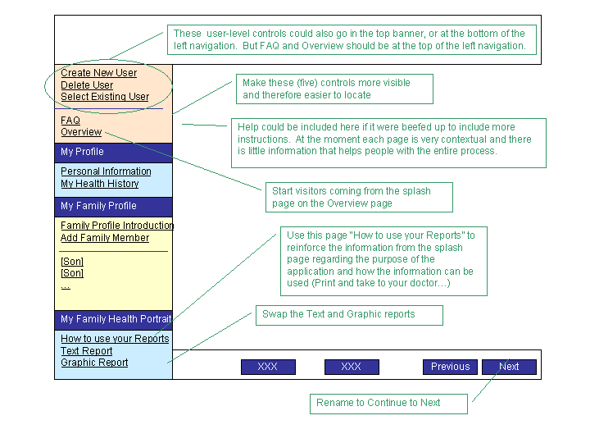

Download Process - Findings & Recommendations (High Priority)
The download process was problematic for some participants. The language was very technical and off-putting for some of them. The table below describes difficulties the participants had with the process.
Note: The Help pages for install aided one participant – he used it to confirm his progress through the process.
Participants found the Security Warning regarding the certificate very off-putting. In order to continue they had to click the radio button that said  “I understand the security risk and wish to continue” | 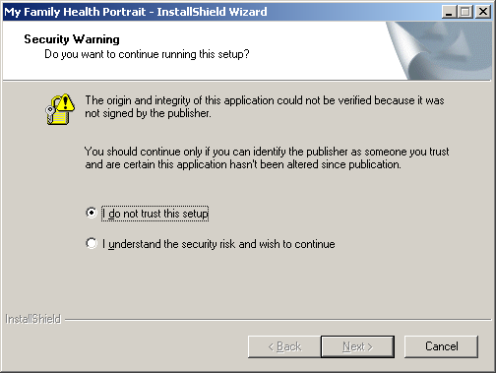

This screen didn’t provide any explanation and the participants clicked through it but were feeling more and more unsure as they went through the process | 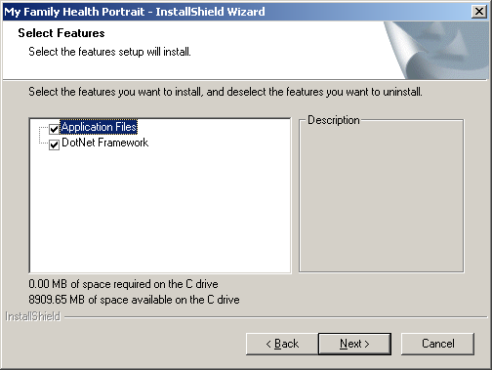

Once the install was complete, the participants did not know what to do next. They had all installed software on their machine before, so it wasn’t their first time, but they weren’t sure that a program had been installed, or where to find it.  Some of them thought that the install process hadn’t worked because when the InstallShield completed, because nothing changed. They were looking at the same screen they had started with (which contains a prominent Install button).  One participants said, after she had clicked the Finish button in the last screen of the InstallShield -- “I have no idea what to do next.” | 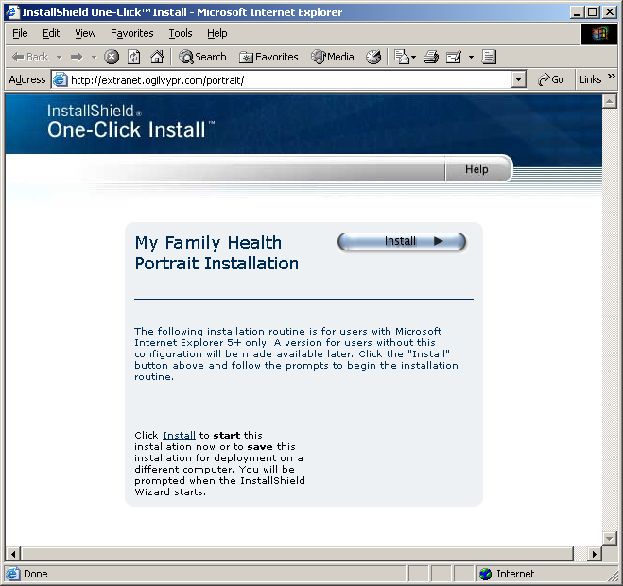

The only way to Uninstall is to start the Install process from the web page and choose on the Remove button on this page. | 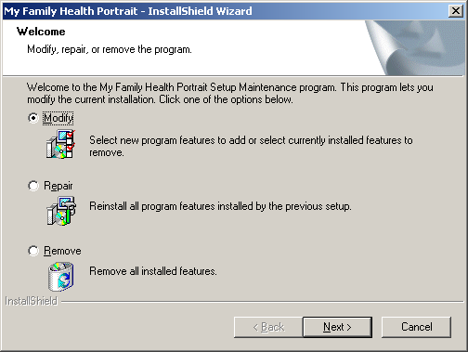

Recommendations for Install Process
- Depending on the browser settings, some users may get not be able to install because they don’t have the right ActiveX installed. At least one participants had no idea that her browser had blocked something when the Alert bar in IE activated. The process for fixing that was “scary”; if she had not had someone walking her through the process, she would not have completed it.
- Register the certificates with the appropriate certificate authorities so users do not have to go through the Security Warning screen.
- Give users the option to run the exe from the web page, or save the exe to their disk and run the install exe on their own.
- Install a program group that includes an Uninstall option
- Install an icon on the desktop for the application (savvy users can move or delete it, less experienced users will need it)
- Provide a final step in the install process that offers to Launch the program.

Appendix B: Sect. 508 Compliance (client tool)
This report was delivered in November 2004 and describes Section 508 compliance issues with the client tool of MFHP and gives recommendations for address the issues.

Section 508 Findings and Recommendations
The picture below marks different sections of the screen layout that this report refers to.
Terminology used in Appendix B
Navigation Bar  Top Menu Bar | 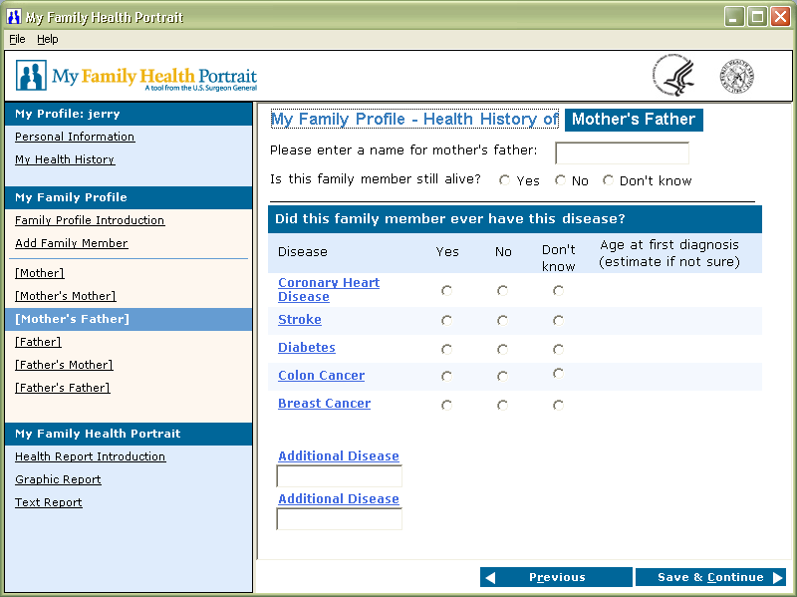  Content Screen  Button Bar

High Priority Findings and Recommendations
This table lists difficulties with MFHP that caused severe difficulties for participants and are important to address.
Area | Observation/Discussion | Recommendation
Help | Help incorrect – arrow keys don’t work as advertised
General Navigation | Tabbing does not move through the necessary functionality.  Tab does not move from the last form field to the Button Bar. Aand the Save & Continue button, the means for moving to the next screen, is on the Button Bar.  As a work around, the label for the final form field on a data screen includes the following text “This is the last form field press Alt-C after completing edit”. However, on the Health History screens, the final form field depends on whether the user enters a second additional disease. If the user enters a second disease the final form field is the Age estimate combo box associated with the second additional disease, otherwise the final form field is the second Additional Disease text-entry box. The final field instructions “xxx” are attached to the Age estimate combo box that becomes active when a second additional disease is entered. In the case where the user does not enter a second Additional Disease, the Age estimate combo box will not activate and so they will not hear the final field instructions “This is the last form field press Alt-C after completing edit”. Instead when they press Tab they will move to the top of the page (and hear the first item on the screen again) and from that information must deduce that they have worked their way back to the beginning of the form and are therefore done with the page and they should move on and guess/remember that the way to move on is to press Alt-C. | Users should be able to cycle through all the screen elements and information on a page by using the Tab key.  - Tabbing off of the final item in the Content Area (read-only text on informational pages or the final form field on data screens) should move to the Button Bar.  - Tabbing off of the Button Bar should move to the top of the Navigation Bar.
Informational pages  Splash Page  Family Profile Introduction  Health Report Introduction | Not all text is read.  Although the full text is available in Help, listening users may not go there to hear the full text of the informational pages. | Read all of the text on informational pages.
Navigation to Add Family Member | Add Family Member easily missed  Add Family Member can only be reached from the Navigation Bar and therefore it is difficult for a listening user to know that Add Family Member is available and locate it. It can be accessed by using the F6 key to move from the Content Screen to the Navigation Bar and then using the Tab or Down-arrow keys to progress through the options on the left. But the listening user must be aware that the Navigation Bar exists (currently that information is only available in the Section 508 Hints in Help). | Make Add Family Member available off of the Top Menu Bar. The Menu bar is a likely place for listening users to explore to learn about available functionality.

Medium Priority Findings and Recommendations
This table lists difficulties with MFHP that caused minor difficulties for participants as well as observations from the facilitator. These should be addressed.

Page/Area | Observation | Recommendation
General | The differentiation between real links and fake links (informational text) is apparent to sighted users, but not to listening users.  In order to make JAWS read the informational text, all informational link text. However, these are not real links, there is no action when the link is followed (pressing the space bar in JAWS). E.g., when the focus is on a disease link, pressing the space bar (to follow the link) moves the focus to the disease description and reads it. When the focus is on information text such as “Did you ever have this disease”, a press on the space bar doesn’t go anywhere.  Also, one common means of navigation for JAWS users is to use JAWS to pull up a list of links on the page. Currently this information is misleading since so many of the items on a page are not “real” links. | Make information text read-only
My Family Profile | Auditory information incomplete  Visually the page makes it clear that mother, father, grandparents are automatically included in the family tree, but that information is not conveyed auditorily. This is particularly problematic since the previous information page, that tells people that parents and grandparents are automatically included, is not entirely read. | Make the information that is conveyed visually available for listeners.

Low Priority Findings and Recommendations
This table lists difficulties with MFHP that caused minor difficulties for participants as well as observations from the facilitator. Addressing these would make the application easier to use but are not critical.
Page/Area | Observation | Recommendation
Splash page | Welcome back to MFHP is not read when page first entered | Read this text.
General | Odd behavior  - Strange text is read when first entering pages  - “Cancel button” when you first entering Text Report page  - “workspace” when first entering My Family Profile – Introduction  - “windows from parking window” when entering Health History page  - Link to “click here for general questions about security and privacy” is read just as “link”  - Splash page  - Reads start of text, but not all text.  - Tab then goes to “a link” - but only the first cycle through the active items on the page  - Tab then goes to new users  - Tab then goes to returning users  - Tab then goes to “info you provide is stored…” even though it is the link that is highlighted | Track down these issues and fix them.
Health Information | Combo-box label is incomplete.  The label for the age-estimate combo box on the Health Information pages is incomplete. | Use the full text for Age estimate combo box  “Age at first diagnosis estimate if not sure” instead of the current abbreviated label  “Age”
Help | Help is incomplete  - Only context sensitive help is provided  - There is no overview | Expand Help to include an overview of the process that users will be walked through.

Appendix C: Survey for client tool
The survey below was posted on the download page for the client version of MFHP. It was available from May 2005 – November 2005. Tables showing the results are listed after the questions.

Survey Questions
OMB #: 0925-0486-0502-01
Exp. 05/31/2007

We would appreciate your feedback. Your answers will help us improve My Family Health Portrait. We expect that providing feedback will take less than five minutes.
Your responses are voluntary and are strictly confidential. (Department of Health and Human Services privacy policy: http://www.hhs.gov/Privacy.html).

- How did you hear about My Family Health Portrait? [check all that apply]
- Newspaper
- Magazine
- Web/Online news
- Healthcare professional (doctor, nurse, medical staff, etc.)
- Family member
- Search engine
- TV
- Radio
- Friend/colleague
- Other (fill-in box)

- How do you think this product could be useful to you? [check all that apply]
- Recording my family health history
- Sharing my family health history with my physician
- Sharing my family health history with family members
- Creating family health histories for other family members
- Need more information

- When you installed My Family Health Portrait it was:
- Easy
- Difficult
- Impossible (unable to install)
- Have not installed yet (skip to question 9)

- How would you rate your overall satisfaction with My Family Health Portrait?
- Very satisfied
- Somewhat satisfied
- Not very satisfied
- Not at all satisfied
- Have installed, but not used it yet
- Have not installed yet

- Please indicate any features that you found helpful. (fill in box)

- Please indicate any features you found limiting. (fill in box)

- How likely are you to recommend My Family Health Portrait to someone else?
- Very likely
- Somewhat likely
- Not very likely
- Don’t know

- Would you prefer a web-based version of My Familty Health Portrait?
(information you entered about your farmily health history would be saved on your computer, not on a government web server)
- Yes
- No
- Not Sure

If No, please tell us your concerns? (fill-in box)

Please tell us a little about yourself

- Gender:
- Female
- Male
- Rather not say

- Age:
- <18 years
- 18-24 years
- 25-34 years
- 35-44 years
- 45-54 years
- > 55 years
- Rather not say

- Zip code: (fill-in box)

- How much time do you spend on the computer a day (home and work)?
- Less than 1 hour a day
- 1 hour to 4 hours a day
- More than 4 hours a day

- Would you be interested in answering additional questions to ensure about your experience with My Family Health Portrait? This would be a 15-25 minutes phone conversation about what worked well, what was difficult or confusing, what was missing or incomplete, so we can adjust My Family Health Portrait to better serve you in the future. If so, please provide the following information so we can contact you.
Name: (fill-in box)
Email address: (fill-in box)
We will keep your information only as long as it takes to contact you. We will not distribute your information to any other group or organization without your permission.

Please press the “Submit Survey” button below to complete the survey. Thank you again for completing the questionnaire.

Submit Survey

Public reporting burden for this collection of information is estimated to average 5 minutes per response, including the time for reviewing instructions, searching existing data sources, gathering and maintaining the data needed, and completing and reviewing the collection of information. An agency may not conduct or sponsor, and a person is not required to respond to, a collection of information unless it displays a currently valid OMB control number. Send comments regarding this burden estimate or any other aspect of this collection of information, including suggestions for reducing this burden, to: NIH, Project Clearance Branch, 6705 Rockledge Drive, MSC 7974, Bethesda, MD 20892-7974, ATTN: PRA (0925-0486). Do not return the completed form to this address.

Survey Results
The table below shows a summary of data from survey on the downloadable client tool posted from May 2005 – November 2006. Cells that start with “See sheet…” refer to free response sections. Those are listed below this initial summarizing table.
An excel sheet of the complete raw data set is also available.
 | Survey Results Summary
 | Total: | 668
1 | How did you hear about My Family Health Portrait ? [check all that apply]
 | Newspaper | Magazine | Web/Online News | Healthcare Professional | Family Member
 | 56 | 165 | 155 | 35 | 27
 | Search Engine | TV | Radio | Friend/Colleague | Other
 | 33 | 19 | 2 | 43 | See sheet "1. How hear about (Other)"
2 | How do you think this product could be useful to you? [check all that apply]
 | Recording | Sharing with physician | Sharing with family | Creating histories for other family members | need more info
 | 531 | 439 | 370 | 78 | 0
3 | When you installed My Family Health Portrait it was:
 | Easy | Difficult | Impossible (unable to install) | Have not installed yet | (skipped, did not answer)
 | 230 | 29 | 91 | 279 | 39
4 | How would you rate your overall satisfaction with My Family Health Portrait?
 | Very satisfied | Somewhat satisfied | Not very satisfied | Not at all satisfied
 | 71 | 99 | 19 | 33
 | Have installed, but not used it yet | Have not installed yet | (skipped, did not answer)
 | 59 | 94 | 446
5 | Please indicate any features that you found helpful. (fill in box)
 | Some complaints, some people appreciative
 | See sheet "5. Helpful features"
6 | Please indicate any features you found limiting. (fill in box)
 | Most common complaints are the need for more than 2 additional diseases, a mac version, & install issues
 | See sheet "6. Limiting"
7 | How likely are you to recommend My Family Health Portrait to someone else?
 | Very likely | Somewhat likely | Not very likely | Don't know | (skipped, did not answer)
 | 149 | 80 | 62 | 83 | 294
8 | Would you prefer a web-based version of My Familty Health Portrait?
 | Yes | No | Not Sure | (skipped, did not answer)
 | 182 | 43 | 103 | 340
9 | Gender
 | Female | Male | Rather not say | (skipped, did not answer)
 | 486 | 136 | 12 | 34
10 | Age
 | 18 to 24 years | 25 to 34 years | 35 to 44 years | 45 to 54 years | gt 55 years
 | 29 | 83 | 95 | 141 | 234
 | Rather not say
 | 23
12 | How much time do you spend on the computer a day (home and work)?
 | Less than 1 hour a day | 1 to 4 hours a day | More than 4 hours a day | (skipped, did not answer)
 | 95 | 302 | 236 | 35
 | Female & over 45 | Male & over 45
 | 279 | 93
 | 42% | 14%
 | These don't total to 100% because there was a Rather Not Say option for both gender and age

1. How did you hear about My Family Health Portrait? (Other responses)
Hospital Magazine
link from pk-research.com
medcare tidbts
place of business
walgreen drug store
Hemaware
Journal article
Employers health program
DeWitt Couonty Genealoyiacl Society
publication from St.John's Health System ---1235 E Cherokee,Springfield,MO 65804 - www.stjohns.com
biology class
mailing
Christian Single Magazine
an email from a friend
Readers Digest
readers digest
Medicare Tidbits
AHIMA PUBLICATION
NIH healthnews email letter
genealogical quarterly
Heakth Coach
Employer's Health Advocate
Health Club
wellness program
Johnson & Johnson
employer wellness website
fitness update from wellness provider
work health online news
Wellness Center
Health Club daily tips email
Corporate wellness
Supervisors
Corporate Daily Health Tip
work
e-mail at work
cdc website
Company e-mail
Family Tree Magazine
2005 HealthCalc.Net
work
email from associate at work
Medicare newsletter
our Health Benefits Dept
reading info on computer
internet search for family health topics
HRSA employee
Medicare insert
Open Records Adoption Site
Readers Digest
Mayo Clinic online
teacher
New England Ancestors
Mailing list
JewishGen Digest
AARP
Betty Duke
Nurse Week Magazine
Church correspondence
genealogy group
doing adoption research on internet
Genealogy Group Meeting
textbook
link from human genome project
mayoclinic article
fellow student used web site as resource
FDA Consumer
surfing from american heart assoc
Genealogy Newsletter
surfing CDC site
Enclosed in Medicare statement
wellness newsletter at work
school
Genetics conference
Somerset Medical Center (NJ) newsletter
school
Medical Library Association exhibit
Please see item 8
college
Required for school U of Tn NSG507
NORD website
Class
Link from Health Expressions E-Newsletter
Health Expressions email newsletter
Link on Mayo website
be healthy thr
Self 2/2005
Medicare Tidbits Issue 21
Mayo Clinic Newsletter
My Health Communication instructor @ASU West
Genealogy Club
school
Stumbled Accross
Teacher
professor
Genetics course at University of Pittsburgh
school
Genetic Alliance
Professor in School of Nursing
why isn't this available for MAX?
college professor
SENOR GARCIA
School Assignment
Johns Hopkins Medical Letter Health After 50
professor
Teacher
County Health Meeting
National organization for rare disorders(NORD)
Healing Hands - News from Mercy Medical Center
Googled "family health history form"
school
Hospital-Phoenix Baptist Mailer
ut memphis school of nursing
school assignment
professor
Ohio Department of Health -Bureau of Nutrition Services (WIC)
support group member friend
Through my college class
University instructor
professor
school
hand out conference
genealogy group
GEHA Keynotes
GEHA newsletter 10/05
TECHER
SURFING FOR HEALTH INFO
GEHA KEYNOTES
GEHA publication
NIH
humana health care plan
teacher
healthcare provider
sorry -- can't remember -- it's been months
My health teacher, Ms Sapp
GEHA Keynotes
School newsletter
Class assignment
teacher
teacher
teacher
teacher
teacher
teacher
my heatlh teacher
teacher
teacher
teacher
Current Health
Current Health 2
listservs
browsing the net on wsaz news
Genealogy society
teacher
Ancestry.com newsletter
ancestry.com newsletter
AT WORK: CDC
Ancestry Daily News
ancestry.com
elca board of pensions
ELCA Board of Pension
ELCA Board of Pensions
Source from Ohio State University Medical Center
Genealogy Rootsweb
roots web newsletter
United Healthcare website
Talk About Sleep message board (narcolepsy)
RootsWeb's Weekly E-zine
www.HealthExpressions.com
genealogy news letter
myuhc.com
press release
Insurance company
Teacher
school

5. Please indicate any features that you found helpful.
not applicable
I liked the family tree..it was extensive and through.
Might want to restrict ages to adults only as to who should be entered.
Easy to enter information on people
My sister and I were just saying that we were going to search the internet to see if we could find a program that would allow us to do just what yours did. I couldn't be happier. I am a nurse and have asked lots of questions over the years, but my siste
Especially liked the graphic family tree.
PLEASE PUT IT ON THE SITE. SOME OF US CAN'T INSTALL IT. I REALLY, REALLY NEED IT SO I CAN HELP MY FAMILY. PLEASE, PLEASE HELP!! THANKS.
Ease of creating the tree
The navigation list on the left side allows me to see exactly who is on the list and go to their page quickly
I liked being able to select illness rather then having to enter them all. Very easy to use.
Simple and intuitive to follow
None
Was not able to get past the download ... defaulted to "Simplified Chinese".
This software takes a special application not supported by my IT dept. Not useful software to my entire company.
more options for more diseases
n/a
Just the overall gathering of important family information to pass along to other family members for future health reference.
more diseases
1. Drop down menu for age brackets. 2. Short cut to any particular family member.
very easy to use
downloading didn't happen easily
Ease of use and graphics
profile printout
ability to navigate program
after down loading on computer i dident know how to get infomationon family histury were is page to sign in
COlor blocking those with identified diseases or health problems.
everything
I could not open/run program said i needed upgrade but still would not work
It was set up to be very user-friendly. It was easy to input my information. I am a family historuan and this type of program will be helpful to share with my family and track risks for hereditary conditions, so that they may discuss them with their healt
None
Could not open it on a MAC!
can't use it at all
None
Don't Know
Check boxes to select disease categories, recommend add more categories. Nicely organized text presentation. Thought the family tree presentation was interesting and useful. But needs more features to be a useful tool
The graphic history tree was helpful in visualizing the history.
The layout of the chart is very good
liked the print out version to take to dr.
The whole thing
Everything!
I like the family tree diagram.
History very useful!
easy to use. i am going to use this format in a class i am teaching.
It did not answer how my family history increase risk for any of these diseases It did not address other diseseases such as high blood pressure or Crohn's disease in my family history
To delinate family health history for other members.
Ease of entering information (from an existing genealogy program with death information extracted into notes)
I couldn't get beyond entering the personal information
Easy, fast, detail family report
Easy to put down information.
Too difficult to install. I've been in a loop with the Net Framework 1.1... thought it installed thru update, but this program can't find it.
Don't know. I have a Mac, so I couldn't install it.
an in place tool
khjgjý7
ease of use
Just having the form is a great reminder to keep track of this important information`
Prompts to keep family member from being confused
I started to fill out the form and it did not take me anywhere.
Arthritis, Eyesight articles
None! I will not install an EXE file, especially one the needlessly requires the .NET program.
Diseases & Age occurred
I just appreciated how easy it was to use.
I would like a version for Mac OS X please.
ease of use
Up and running very simply! Excellent for my non-computer saavy family members.
the graphic map
automatic construction of family tree
Assembling a family health tree
Why is this not available for MAC operating systems?
graphic "map" of family history
Placing photos, adding additional history like social, religious, physical, financial, educational, and mental.
Connect cousins to parents in a form of a family tree.
health links
Listing of major health problems.
info and ease of use
the "interview" type format
It was very easy to install.
It's a good start to keep track of family medical records.
Fairly easy to get started.
none, i can't even get in to the program, it pretty much just made me angry.
It was very easy to use.
lists of genetic linked diseases
The ability to add rare genetic disorders versus common diseases.
n/a
need additional boxes for other diseases needs additional age bracket over 60
XCVXFGFXG
easy to navigate back to family members to update info.
I HAVEN'T READ THE ENTIRE SITE. I JUST MET SOMEONE WHO IS A RESEARCHER AT NIH AND I WAS INTERESTED IN FINDING OUT ABOUT GENOME RESEARCH.
Genogram
the entry was easy
It was helpful to ploy diseases and deaths
It was user friendly
I hate you. yourweb site is pretty damn horrible. F.U.
I hate you. yourweb site is pretty damn horrible. F.U.
IT WONT DOWNLOAD
Compilation of the results to show what your chances are for getting the disease.
The adoption thing
Portrait
learning about my family
getting family history
Could not download, ended up in a circular series of dialgo boxes
I like the idea of having a program to input information.
I can not get it to download.
could not install it!
I like the text report with columns for each disorder. I also like the family tree, but wish it could all be on one page.
the generational pages - good reminders to check out
Easy to use
The Chart that can be printed out.
form itself
Very easy and clear...especially liked the graphic display

6. Please indicate any features you found limiting.
size of the spaces on the printed version
No details on one's genetic prediction. No age for death and length of one's life prediction. No information on life style. I question the value of the information?
Cannot run the software on the Macintosh platform. I think that this is a wonderful idea. I only wish that I and the milliions of other Macintosh users had access to the program.
There wasn't enough room to put diseases. You limited the diseases to certain ones and only left spaces for two more things..what about when there is more?? what about surgeries??
Need many more places to enter additional health issues. Only two extra makes this program useless to me because we have many more health issues to track.
doesn't run on a MAC?
could have been more areas for added disease entities that weren't listed.
Some family members had more than two additional medical conditions that I wold have liked to have included.
My computer indicates download successful, but I cannot find it anywhere! If possible, send e-mail to bobbiede48473@comcast.net with assistance hints
Requirement to have Microsoft NET installed. I don't let that dog in the door- it leaves messes all over.
Did not include near enough diseases. What about lung cancer or other lung disease, high blood pressure, thyroid problems?
The 15-character limit in the box for entering names. I have a couple of family members who have more than 15 letters in thier name.
I cannot add a secong disease
I cannot enter dates od death and cause of death. I also cannot merge my husband and my histories. I am using this for my pregnancy to gather info and it would work better if we could combine them since our child is a combination! Also, a way to email it
I do not yet understand the red slashes in the graphic report.
No Macintosh or Linux version, no alternatives to Windows provided.
Would like for it to handle more clusters, without having to re-enter the information, e.g., creating it based on myself, once, then creating it based on my mother, for her generation, cousins, etc.
Required I install .NET Framework 1.1. Seems program can't universally be installed since many other users won't have this software.
disease, what ones were options and how many you could add
I am a Linux user and am unable to install this program as it only supports Windows operating systems. I would very much like to try it and hope that more operating systems will be supported in the future. Thank you for creating this tool, I think it's
Could not be installed on an Apple MacIntosh
Scroll bar is not available after filling in Personal Information. Cannot proceed to next step.
Installation. You do not give the explicit link for Microsoft .NET Framwork 1.1, and I tried a few things, but still get an error message when I try to load the Health Portrait.
1. For some family members, the program would not properly save and print out a second "Additional Disease", even though it appeared to take the input. 2. Unfortunately, more than two "additional disease" inputs should be provided for each family member
illness/conditions too narrow. character allowance for name too small. cause of death category, if known, would be helpful.
Your number of disease states is limited, it does not include other cancers, hereditry diseases and mental health issues or unlimited space to write "other" conditions.
I want to download this to my Macintosh OS X. I am very disappointed that you initiative does not recognize Macintosh.
Disease catagories
Program does not allow for editing info once entered(ie, adding an additional disease
I can't download on my MAC. Please do a version which is applicable to MAC users.
The fact that it says downloading is done but there's nothing there. I have Windows XP and usually don't have any trouble downloading what I want to.
I wanted to enter illnesses or medical conditions which have been discovered since I completed my part and the program will not let me do that. It would be great if it were programmed to let one add to the original documentation!
Cousins should be linked to the appropriate aunt or uncle for better health history representation.
Need to install on a Mac. PLEASE develop a Mac version. There are serious health issues in our family that need to be documented.
Only two places to add additional illnesses ... were not enough
inability to complete birthfather information. Bmother died before finding birthfamily of breast cancer in 1987. Found in 2004. Searched for 24 years.
Since this requires the purchase of WinZip, I cannot use it.
I would have liked more space to input numerous other conditions sufferd by myself & family.
The software does not run on a Macintosh and so is useless to me. Too bad.
Only works on Windows, so I can't use it on my computer (which does NOT run Windows)
Could not open the Zip file on a MAC for some reason
Only Windows? How about a simple doc file or pdf file. There are other (and older) computers in use. Why are you helping Microsoft????
Spaces too small to write much. Would like a software-based application product that can work with my Family Tree Maker genealogy software program. I already record medical data there.
Once you type the report, although you can go back and update it, the initial date stays the same.
My computer's in great shape but several years old. I was unable to install because the program said I needed and upgrade. I downloaded the new service pack and then the program said I needed something. So I tried to download the paper copy and that did
Date of death
Is in EXE code. I have a Macintosh
can Only document 3 generations. One of my g-grandfathers was the last relative to have diabetes in my line, but it was common within his family & their descendants.
Needs to be in Microsoft Word format.
The text tree did not function on my computer, so I did not receive any interpretation to the results. I also think that there could be more explanation of the diseases. Should depression be included?
I didn't like that you needed 81/2 by 14 paper it's not a size That I usually have. You might consider downsizing to 81/2 by 11.
the downloadable program did not save some of my answers in the blank spaces for additional diseases.
The nieces and nephews didn't print out on the pedigree. You could have asked "sister's daughters and sons" and then printed them under her in the pedigree.
I would like to see more "conditions" listed for family history, including epilepsy and other disorders. In addition, I would like to see more family generations available to enter information.
The lack of some serious health problems.
Not enough blank spaces for each family member; No easy file save option for using on different computers.
didn't include siblings
I would like the ability to "hide" my health history, while ancestors health is displayed, who are deceased.
Could not install it on my NIH computer.
I wish there were more disease options listed...such as emotional illness, accidents, suicide, etc. However the fill in options work. ALSO...wish there was an easy way to forward these results to family members (rather than an attachment) for computer ill
see above
having to install microsoft.NET framework.
Need more relatives listed. Need more Diseases Listed. Such as cancer. I know more people that have died of Cancer than any other disease.
It is incompatible with my operating system.
none
louýjghjhngb
I couldn't download the Microsoft.NET framework 1.1. I just keep getting a window that says, "Thank you." and nothing else. I tried everything I could think of, but haven't been able to get that software, so the Family Health History Software is useless
I need a version for imac computer
would like it to configure to print on single pages. ability to include more information, unrelated spouses, to document psycosocial aspects
There wasn't really enough space to write down notes on all the health conditions
It was more than a little difficult to find the file "Microsoft.NET Framework 1.1"! Anyone less persistent than I am would have failed.
It cut off after I did my fathers-mother. I did not get to do my fathers-father
I could not use My Family Health Portrait since I do not have Microsoft.net framework on my computer.
none
There is no need to do this with an invasive EXE program, especially one that needlessly requires the untrustwothy .NET program. I'm sure you can accomplish the same with an online form, a PDF file or even an OpenOffice file. I will not install this, and
The website should have been designed so that people would able to just click and print the "My Family Health Portrait". I tried to do an on-line order, but it would only be mailed to me. Why not an e-mail response? When I filled out the form to order
Not enough boxes for diseases & Age
Couldn't get past Family Profile Intro. No continue button to push. Couldn't figure out how to get to next page. Very disappointed. Let me know when you fix it. Thanks!--------dbsweat@yahoo.com
I was surprised that alcoholism wasn't listed. My family "portrait" would have looked a lot different if it were. Same thing with obesity.
Not Mac compatible
Brother is younger, but listed before me on tree, and he is half-brother on mother's side, but listed under both of my parents. Would like to see an "Add disease" feature for family members with additional diagnoses. Would like to see a spouse addition f
selection of diseases
It only lists a few diseases. I understand that it has a list for other, but most people don't know what they should include as other. Maybe just adding a list for what other useful diseases on a family medical chart would be. Some disease are not here
my family members have far more illnesses than are allowed to be entered and some of these are genetically based.
Does not account for mixed families
not available for MAC operating systems!
Two things: 1. I'd like to be able to add my husband and his family history for my children to have. 2. I'd like to add more than 2 "other" diseases.
Only listing diseases.
Enable entry of more then one medical condition per individual. I was able to enter only one in addition to those pre-populated.
software
Printing of My Family Profile was too large and wasted paper.
only having room for two "additional disease" categories for each person
I haven't figured out how to put in my partner's profile yetg.
Space for more than two diseases for people other than the big ones.
Not enough blanks for some complex health problems.
I needed some software component, that I didn't have, to use the program.
could not download program; it would not "initialize."
Printing features-not all the information printed correctly no matter how my paper was formatted, should notify people to make sure screen is open fully...don't realize it until you can't find the continue button.
I use an iMac so am unable to install your software. I would very much like something compatible with my system
Not enough additional disease fields. Should be able to go back to Great Grandparents if you know that history. As a 3rd generation only child, a lot more is revealed about my family health history when you add Great Grandparents.
lack of "other" diseases
Don't know how to add cousin's to their appropriate parents.
Printing the family chart.
no Macintosh version
Since all the information was entered by me, it didn't tell me anything I didn't already know. There's no place for potentially helpful inormation about a family member such as age at death/cause of death. The reports are hard to read since they run off t
Use a Mac computer so can not use
other diseases
XCVXCVXCV
not enough spaces for additional diseases or conditions, could not specify half-brothers or sisters, nieces and nephews were not linked to their parent, did not itentify trends or possible genetic links
Inflexibility of data entry fields.
limited number of areas to put additional diseases. Also, define how the listed diseases are defined, ie if you had a heart attack, is this coronary heart disease, or if you have hypertension, or just chest pain. Confusing to some lay people.
It is too hard to install. I don't know how to use winzip.
Should have been easier to print. Could not control the size of the graph which would have made it much easier to read and use.
It would be nice to make notes expanding families health issues to better document health care, I'd also like to email these forms to family to fill out
there wasnt any pie. your fuckin' web site is the worst excuse for anything ever I know where you live....Jeffry
there wasnt any pie. your fuckin' web site is the worst excuse for anything ever I know where you live....Jeffry
I NEED IT FOR HOMEWORK
none
none
none
The program itself was not completely useful. I accidentally put in the wrong number of brothers and couldn't go back to change it. I had to start all over. I couldn't indicate half/step brothers and sisters, and people in the family who were adopted. I c
I would have liked to indicate at what age family members died and of what disease.
Does not work on Apple Mac computers or Apple OS
Program would not download with my installing Microsoft.NET Framework 1.1. Microsoft would not allow me to add only this program. When I tried to just download the paper version, Health Portrait was not recognized by Adobe.
Installation
There was only space for 2 disorders for each family member--I would have liked to have added more diseases for some. I would like to run a report for my husband without having to download the same software a second time. I'd like to have space for commen
I felt it need a note section
I couldn't go back and add anything if I needed to
No acknowledgement of non-biological relatives
print out
having problems editing disease list with individuals; especially My list; it does not save it; 2)limited to 2 addl diseases; 3) for males there should be a primary disease for prostate cancer replacing the breast cancer choice
Will not run on my NIH computer!

Appendix D: Usability Testing & 508-compliance Assessment (web version)
The tables below show findings and recommendations for addressing issues and are organized by page, and sometimes by priority depending on when they were delivered and acted on. Also, some pages changed their names to make them more intuitive over the course of the usability testing sessions. For example, earlier tables of findings/recommendations refer to the Graphic and Text Reports. Usability testing revealed that those terms were too technical and the names of the pages were changed to Drawing and Chart Reports respectively. So as you read through the comments below there will be some changes in the names/titles used to refer to the page in the left column.

Findings and Recommendations: Usability Testing with Stakeholders
This section summarizes a report that was delivered in July 2005 on initial usability testing results with the web version of MFHP. The usability test sessions were conducted in June and July 2005. The participants were key stakeholders - participants from government and private organizations who partnered with NHGRI in the planning of MFHP. Although these participants were familiar with the purpose of MFHP, their family health histories were highly varied and observing them entering their family history provided useful feedback for improving the screen layout and flow of MFHP. Participants were asked to use the MFHP and “think aloud” as they worked in order to share their thoughts and first-hand reactions with the observer as they worked through the screens. Difficulties and comments were recorded by the facilitator and captured in the table below along with recommendations for addressing the issues. Also, since this round of testing was iterative there are certain table entries that are marked as a change (+) to show that a significant modification was made to fix an area of difficulty during the course of testing.
Page | Raw comments from testers & facilitator observations | Recommendations
Splash | Too barebones; there isn’t enough information on the splash page.  Needs disclaimer and more explanation of the process | Add this information to the Splash page:  Whatever you have will be useful, even if you don’t know all the details about everyone in your family  Explain saving process (stored on your computer only, not to gov’t server). You own the file and can choose what to do with it.  Can edit/update your information any time.  You can save it to a disk and take it with you if you are on a public machine (e.g., at the library) and view/edit it a later time from any machine with an internet connection.  You can choose who to share it with  How to share the file (e.g., mail it to someone). Emphasize that the file will not be usable without an internet connection.
 | There isn’t a EULA. Is it necessary? | Check whether a EULA is necessary for a web-based application and add if it is needed.
 | One participant revisited the splash page and was unsure when/why she would want to use the Load option. (note: she had already successfully saved a file and also viewed the saved file by double-clicking on it on her hard-drive and so had circumvented the Load process. | Clearly explain that the Create A Family History button is for new users and the Load a Saved Family History button is for returning users.
Personal Info | Why is age captured instead of DOB?
Personal Info | Name? Which one (first or last) | Everyone had this same question, but everyone figured out something to put in a moved on
Personal Info | Which info is optional? Which is mandatory? How will the info be used?  Some women will be uncomfortable entering the weight, and possibly also their height. Could be a barrier-to-use. Could be a barrier to sharing if it is on the Text/Graphic Reports. | Mark which information is optional (all of it…)  Provide brief explanation on how the info will be used?
Personal Info | Height – should say w/o shoes to be consistent with parenthetical note for weight
HH [me] | One participant not sure what “at a later time” means in the Note:. Later in this session? Tomorrow? | Provide brief explanation or link to explanation
HH [me] | Participant unsure what to enter for Additional Diseases if she doesn’t have any. She isn’t sure she can leave it blank. | Mark the Additional Disease field as optional.
Create Family Tree | Some participants wondered why aunts and uncles weren’t listed on this page. | Add a Note to the bottom telling users that they will be able to enter additional family members later.
Create Family Tree | Some participants noted that the male/female order was inconsistent. | Make the order consistent
Create Family Tree | One participant was unsure if half-siblings (same father) referred her half siblings or her kid’s half-siblings because she just got done entering numbers for her son and daughters. | Consider re-ordering to keep it generational E.g., parents, siblings, half-siblings, then children
Create Family Tree | A few participants wondered why only identical twins for oneself and one’s parents were mentioned and not identical twins elsewhere on the family tree. E.g., why doesn’t it ask about grandparents who have an identical twin | Provide brief explanation or link to explanation in the Help and FAQ sections.
Bootstrap Process | A majority of participants wanted to go back and edit a previous relative during the bootstrap process. As they were entering their family they would remember something they forgot on a relative they had already entered. Although there was a note telling them they would be able to go back and edit relatives later, they did not want to wait, they wanted to do it right then while they were thinking about it. |  Changed after first few test sessions to address this issue: Save & Go Back button on bootstrap pages
Bootstrap Process | Everyone noticed the progress box at some point and found it helpful. | Keep it!
Bootstrap Process | Participants were confused when the Save & Go Back and Save & Continue did not behave as expected. The Save and Go Back goes back one page (as expected), but the Save & Continue button goes the next unedited/saved relative on the list which may not always be the next person on the list. E.g., person X has relatives A B C,  works on A, presses Save & Continue  Completes B, presses Save & go Back which goes back to A (as expected)  Edits A, presses Save & Continue (which skips B and moves to C, because B is complete) That behavior was unintuitive to participants. | Support the expected behavior even though it isn’t the most efficient behavior. Move sequentially through the relatives with the Save & Continue button. I.e., always move the next relative in the list.
HH [relative] | Participants unsure which name (first, last, full) to put into the Name field. | Not a major stumbling block. Leave as is. All participants quickly made a decision about what to enter (first, last, or full) and moved on.
HH [relative] | One participant didn’t know what to put because she doesn’t know the relative’s name. Decided to put in “unknown”. Another participant with the same issue decided to leave it blank | Add an explanation in the Help section that using “unknown” or leaving it blank are both fine in situations where the relative’s name is not known.
HH [relative] | A couple of participants were unsure whether some relatives were deceased. | Add an unknown radio button to the “Is this relative alive?” question.
HH [relative] | Several participants commented that the age of relatives who are healthy is important information to capture. E.g., in a family with a history of brCa after age 50 if there is a relative who hasn’t had BC and is over 50, that is different info than a relative who hasn’t had BC and is in her 20s. | Consider capturing the ages (or DOB) of relatives.
HH [relative] | Some participants unsure what should go under Additional Diseases and wanted guidance. | Provide a link that offers a page with guidance on what to enter under Additional Diseases.
HH [relative] | Wonders if the disease boxes should be longer (accommodate and show more characters) since many disease names have long monikers
HH [relative] | Some participants noted that the male/female order was not consistent. | Use a consistent male/female order. Keep it consistent with the order on the Create Family Tree page as well.
HH [relative] | Some participants suggested it would be more intuitive to enter the relatives from the same generation before moving onto the children. | Re-order the relatives to it is generational (grandparents, parents, siblings, children)
HH [relative] | Some participants suggested it would be less error-prone to define the half-siblings very specifically. | List the half-siblings according to both gender and related parent  Half-sister (same mother)  Half-brother (same mother)  Half-sister (same father)  Half-brother (same father)
HH [relative] | Several participants had difficulty with the Parent dropdown because they had not yet entered the parent and therefore the parent wasn’t in the list. E.g., entering cousins before entering aunts and uncles |  Changed mid-way through testing sessions: A Note to Add Family Members page and each [relative] page with a Parent dropdown that recommended people enter parents before children (e.g., aunts and uncles before cousins)
HH [relative] | Although an explanatory note was added below the Parent dropdown, not all participants way it.  The Note was effective for the participants that read it. | Make the note more prominent  Add a placeholder “[ relative ]” designation to the dropdown as well. That way if one of them has a blank for a name, at least something will show. (This won’t fix the problem of the parent not being entered yet)
HH [relative] | One participant was not sure what “missing” meant in the Note. | Clarify that “missing” means not visible in the dropdown, not missing in general.
Add Family Members | Two participants (using the original dropdown for adding relatives that was on this page) accidently end up with several more relatives than they needed and were confused about why that happened and how to get rid of the extra |  Change during testing:  Changed the Add Family Members page to look like the Create Family Tree page (show all possible relatives and provide type-in boxes for each).  Added Delete this Relative link to the [ relative ] pages during the bootstrap process.
Add Family Members | One participant found the language “Father’s Sister”, etc., unintuitive. She was expecting to see “Aunt”, “Uncle” | Compromise and use both terms:  Aunt – Mother’s Sister  Aunt – Father’s Sister  Uncle – Mother’s Brother  Uncle – Father’s Brother
Add Family Members | One participant added 2nd degree nieces and nephews. | Add explanation to the top of the page to only add 1st degree blood relatives. And explain why.
My Family | Need to provide access to the info given on the splash page
My Family | Most participants had a moment of “what do I do next” when they first landed on the My Family page. They were just been dumped out of a step-by-step process; this was the first page where they had a navigation decision to make. Despite this, they figured out something to do next (add, view, save) after a moment of processing the page.  Some participants assumed an implied order to the actions based on their order on the page. | Provide more hints/info on the Action links. Order the Action links so the most important actions are at the top of the list.
My Family | Some participants unsure what will happen when they click Save My Data to My Computer  Quote: “I’m not sure what will happen when I click on this and I want to know before I click on it because I’m at work” | Relates to above item – need guidance for people on this page
My Family | Quote: “These commands (Actions) are too bunched up – it is hard to tell them apart. And they are easy to miss because they don’t stand out.” | Separate the actions so there is one per line rather than stringing them horizontally across the top.
My Family | Just about all the participants momentarily wondered (aloud) why there was no Delete option for some relatives (parents and grandparents) | Add an explanatory Note
My Family | Progress bar reactions  Participants were not completely sure what it was, especially if they thought they entered all the information for each person.  The meaning of the progress bars was particularly unintuitive when the participant had completed all the necessary information and therefore the bars were all completely filled in.  One participant though “Progress” was the wrong label because it is the system’s assessment of whether the info is complete. She suggested that the person entering the info should be able to indicate whether the info is complete or not.  I.e., even though alive/dead for Uncle Joe isn’t marked, the info really is complete because the person doesn’t know if Uncle Joe is dead or alive. | Add an explanatory NOTE about the progress bar.  Although it would be helpful to allow participants to indicate which information they considered crucial in completing a relative’s health history, adding that functionality would an uninviting level of complexity to the application.
My Family | Participants asked for the ability to re-use information they have entered about themselves and their relatives to create family histories for other family members. | This functionality was also requested in the survey results. Should implement this functionality and test it..  Possible labels  Save my data as another relative  Save As Relative  Use my data for a relative
My Family | Quote: “I’m all done, what do I do next?” | Consider a formal “Done” button that would exit tool.
My Family | The system doesn’t check whether identical twins were ever marked. | Provide an error message if/when the person indicated there were identical twins but didn’t mark which relatives were the identical twins.
Save | Most participants, rather than reading the instructions, tried to click on the instructional images, thinking the images were the actual dialog boxes.  Participants were missing the instructions because they were small (and visually diminished) next to the large screen shots.  Participants were clicking on Open, rather than Close in the dialog box presented by the browser at the end of the save process. And that resulted in their having multiple browser windows open with their family history. They often didn’t realize that they were opening multiple browser windows. and often didn’t realize it) |  Changed during testing: Added new instructions that  Use partial screen shots with callouts (to clarify that these are pictures of the process, not the actual item to be clicked on)  Visuals (big text, border, background color) on the instructions to make them visually equal to the screen shots.  Added final instructions about clicking on Close, not Open, on the Download Complete dialog box.  Better success with the modified instructions
Save | What will happen with my file, where is it saved? | Add more explanation about the process of saving and retrieving files
Save | Several testers saved and then went and located the file on their disk and opened it to see what it would show. They then had two browser windows open with their FH.
Save | Working with new instructions  Scrolls to bottom of screen before starting. Tries, gets stuck. Reads instructions. Success.  Checks afterwards to be sure can find and open file. Wants to see what happens when you click on the saved file.  Need language describing the process of saving the file and how things will work in the future once you have saved file to work with. Also tell people that if they don’t save, their information will not be retrievable. | Add more explanation about the process of saving and retrieving files
Load | Several testers skipped the Load instructions – just went and found their file and opened it from there.
 | Didn’t read instructions, tries to wing it - failure |  Changed during testing: New instructions that  Use partial screen shots with callouts (to clarify that these are pictures of the process, not the actual item to be clicked on)  Visuals (big text, border, background color) on the instructions. (previously people were missing the instructions because they were small (and visually diminished) next to the screen shots.  Better success with the modified instructions  Problem: On the Load, once the File | Open dialog box is open, you can’t go back to the instructions page to scroll down to see what to do next. You have to Cancel, go back read the instructions more fully, and try again.  People did better when they read through the instructions first.
Text Report | Want a direct path from Text Report back to View Reports |  Added during testing: Link for “Back to View Reports”
Text Report | Identical twin info suggestions from testers  Put with personal info or with parent as appropriate  Put as footnotes
Text Report | Why is BMI 2 decimals places, should only show to one decimal place.
Text Report | Not everyone will know what BMI means, needs an explanation
Text Report | Some people will not want to share the Text Report if it lists personal information such as age, weight, BMI. Could keep them from bringing it around at family gatherings to get it filled in. | Serious point to consider.  Could offer a version that doesn’t have that information  This ties in with telling people that all the fields are optional on the Personal Info page.
Text Report | The text is strange. Makes it sound like you can’t even look at it without a doctor present. Should be more relaxed and friendlier, not to direct. Should use common language. E.g., doctor instead of health care professional
Text Report | Print Text Report – should include the Back to XXX links | Remove the Back to XXX links on the printed version (when the person uses the Print Text Report link)
Text Report | Many people used the Text Report to check that their edits were really happening.
View Reports | Doesn’t like language, proposed new language |  Change during testing: New language for this page.
View Reports | Poor connection between Text Report and Graphic Report and the language in the preceeding paragraphs  (this is when the language was the same as the .NET version) |  Changed during testing: New layout for this page and language tweaks
View Reports | Need Back to xxx options at bottom too
Graphic Report | Not working on the public side so not all participants saw it |  Changed during testing: Link for “Back to View Reports”
Graphic Report | People with conditions should be in blue
Graphic Report | The “graphic report” shows only people, nothing about their health histories – nice for genealogy, but not much for genetics.
Visuals | Logos too small
Visuals | Her browser window is at max stretch and the progress box is all the way at the right edge – she says that makes it harder to pay attention to it because it is so far away. | Maybe center the info and put extra white space on the sides rather than between the areas?  If that happens, should center the header as well.
General  Technical | One tester was in IE at 800x600. The divs weren’t in the same vertical plane. | Fixed.  Test across modern browsers.
General  Technical | Tried app in NS4.75 (yikes!) | Add browser checks into code
General  Technical | Print version shouldn’t include the navigation (Back to xxx, Back to yyy, Back to zzz)
General  Technical | Hitting the Enter key anywhere in the form and triggers the Save & Continue button whether or not the person is ready to move on. | Can this be fixed? Only move on if the focus is on the button?

Findings and Recommendations: Iterative Usability Testing with Representative End-users and Sect. 508-compliance Assessment (web version)
This section is organized differently than previous appendices of usability testing results. During the fall of 2005 the web-team met weekly to discuss ways to address usability issues and other functional aspects with the web-based MFHP. Recommendations from the facilitator were considered but the web-team made the final decision. The sections below are weekly findings and recommendations delivered to the web-team for discussion. These notes are terse because they were simply reminders of points to discuss in the meeting.

Iterative Usability & Sect. 508-compliance Testing Results10/06/05
Page | Recommendation | Observations & raw comments from participants | Priority
Personal Info | Remove (without shoes) from weight & height | It gets comments from all participants – they all find it an odd thing to mention. | 3Low
All pages | Make the HTML alt text be the same text as the button. E.g., instead of “Click here if you need help with this page” shorten it to “help with this page” | 508 issue  This will be less text for screen readers to read people listening to the page with screen readers | 1High
Drawing Report | Add “Print this Page” button | Participants were not always sure what to do with the reports. By providing a print button it will help emphasize that one of the purposes of the tool is to print reports. | 1High
Create Family Tree | Center input boxes (to match the centered column header) | Inconsistency noticed during participant testing session | 3Low
My Family | Remove leading spaces on names in the Notes section. | Inconsistency noticed during participant testing session | 3Low
My Family | Please rearrange the links and add the parenthetical note to View Reports as per mockup (below table). This will move the two most important items to the top and the parenteitical phrases will provide more guidance. | Participants were unsure when they reached this page. | 1High
My Family | Update the text about the progress bars – they are no longer blue… | Inconsistency noticed during participant testing session | 2Med
Save As instructions | Add detailed instructions for common OS/browser combinations. This can be limited to Windows/IE and Mac/Safari until it’s efficacy is shown during future usability testing. | Participants are having difficulty with the Save As process. They need their hand held because it is not (quite) the same as saving from an application. | 1High
HH pages | Add ? icon back in and link it to the disease info, instead linking from disease name | Although the disease names are linked to explanations, not all participants notice, even though they are muttering about not knowing what Heart Disease covers. An icon should draw their attention more. | 2Med
Frameset in Help | Provide name and title attributes for each FRAME element in the FRAMESET that make present the purpose of the frame clear.  “Menu” and “Main Content”  Provide TITLE elements for each frame page. | 508 issue | 1High
HH pages | Add an additional Note below the Next button  “Although rare, men can get breast cancer” | All participants think that the tool is broken/confused when it lists breast cancer as a choice for men. | 2Med
HH pages | Additional Diseases needs ? icon that links to explanation as well. | Participants really weren’t sure what to put in here and wanted guidance. | 1High
View Reports | Change so it looks like spotstripe mockup (URL at bottom of table).  Make the form more consistent.  Change the language to more consumer-level language (Graphical to Drawing, Text to Chart.)  Gives a radio button for “don’t highlight anything.”  Makes the Chart report the default option | Participants had a negative reaction to “Text Report” - they associated it with a lot of words.  Participants like to view the tree but when they see the Chart they say “now this is useful.” | 1High
Text Report | Add HTML ID and HEADERS attributes to the columns and rows | 508 issue | 2Med
Add Family Members | Add HTML ID and HEADERS attributes to the columns and rows.  Give the input boxes HTML LABELS.  see example below table | 508 issue  A screen reader user can jump to the form and then enter forms mode. Once they do that, all they hear is the label associated with that form. | 2Med
Create Family Tree | Add HTLM ID and HEADERS attributes to the columns and rows.  Give the input boxes HTML LABELS. | A screen reader user can jump to the form and then enter forms mode. Once they do that, all they hear is the label associated with that form. | 2Med
Text/Graphical report | *** Bug fix. Currently displays personal info even when the “Do not display personal info” box is checked. |  | 1High
Graphical report | *** Bug fix: not all people with breast cancer are highlighted | from Joanne | 1High
text Report | empty [ ] should be [ N/A ] | Inconsistency noticed during participant testing session | 2Med
Help | Have the Help with this Page buttons pull up just the help for that page (without the frameset and with Close Window links at the top and the bottom). Like the disease links currently work.  Reason: It would be tightly focused help – help just for this page. It would be more obvious that this is help for that page. It would keep people from getting lost in the help (because they think they are still in the application and trying to use the links on the left in the help to “do things”).  Have the entire Help system (the frame set) available from the Help link in the footer.  Reason: The entire Help system would still be available, but not so prominent. | When Participants visit the Help section they get thrown off. What they see down the left looks like a series of actions they can take (yes that the column is labeled Help Topics…but participants didn’t notice). They thought they were just in another part of the application. To quote one participant: “Create family tree, that’s what I want to do”…[she then went to that help page] .. “this [referring to the text on the page] is no good. It has all my data, how do I make it create my family tree?” She clearly did not understand that this was a page of explanation for how to use the Create Family Tree page, not the actual Create Family Tree page itself. | 1High

Iterative Usability & Sect. 508-compliance Testing Results10/13/05

Page | Recommendation | Observations & raw comments from participants | Priority
Create Family | Add the “Steps towards completing your family health…” header. It is on the previous page (HH [me]), but not this one |  | 1Low
FAQs | Add these questions:  What is the difference between fraternal and identical twins?  I have children who are twins. Why doesn't MyFamilyHealthPortrait record that information?  I am a triplets (or quadruplets, etc.). How do I record that information in MyFamilyHealth Portrait?  Why doesn't MFHP record information about my spouse and my spouse's family?  Why doesn't MFHP record information about my grandchildren?  Why aren’t more diseases listed? | These are questions participants are sometimes asking as they use the tool. | 1Low
Personal Info | Show progress box on this page | For consistency | 1Low
Splash page | Bug fix: Link directly to the MFHP FAQ page in HHS rather than the general HHS FAQ. | Currently goes to the general HHS FAQ instead of directly to the MFHP section. | 1Low
Add Family | Add text at top about only adding first-degree blood relatives. | Some participants want to enter adopted and/or distant relatives. | 2Med
Banner | Split the top-right logo into two images that can use alt text instead of an image map | 508 issue.  Separate images are more straightforward than an image map. | 2Med
Banner | Make the alt text on the MFHP “MFHP” | 508 issue | 2Med
Chart | Highlighting on columns is too faint | Several participants have commented that they think the columns are highlighted, but it is so faint they can’t quite tell. | 1Low
Help | Don’t use frameset when opening a single help page (the page that comes from a click on Help With This Page).  Add Close Window link at the bottom each Help page | For consistency. | 2Med
HH [ relative ]  Parent dropdown | When a potential parent doesn’t have a name yet, list their designation instead. E.g., [mother’s sister 1] instead of the blanks. That’s more informative than blanks, especially when there are several in the list without names. | Bug fix | 2Med
HH pages | Synchronize the progress check boxes and the green progress bar on the My Fmaily page.  Currently it is possible to not have all the fields entered and have the box be red (indicating all is well), but have the green progress box on the My Family page not be fully green (indicating incomplete). | Bug fix | 2Med
Print Chart | Print Chart button prints the buttons and it shouldn’t | Bug fix | 2Med
Print Drawing | Print Drawing button prints the buttons and it shouldn’t | Bug fix | 2Med
HH [relative ] | Next is moving from last female cousin directly to My Family, even if there are male cousins below the female cousins. | Bug fix | 3High
Invisible Divs for ? icons | Make the ? icons link to the same thing as the disease name.  i.e. ditch the invisible divs  Add a link below the table, right justified that pulls up a Help page with the bottom of the help for that page. On that help page start with the part that begins “For quick reference…” and add the paragraph from above gives guidelines on what to include for additional diseases  See mockup (URL below) | Participants wanted the information to stay up while they worked on filling in info. Particularly the info about what to put for additional diseases.  They didn’t like that it disappeared when they clicked someplace else. The text was small and difficult to read for some participants  The text for Heart Disease is likely to become longer and list conditions at which point people will really want it to stay up longer and it won’t fit well in the invisible div. Same for Stroke. | 3High
Print Drawing | Cuts off in Firefox. Right half (second page) is blank | Bug fix | 3High
Save As | Save As is losing data.  If you save as your sister, the sister file will show your (mutual) parents as incomplete even if your (mutual) parents are complete in your file.  If you save as your mother, it loses you and your siblings | Bug fix | 3High
Splash | We need to move the note about the client tool someplace else and make the language more complete.  Ideas? | It really really confused some participants who had no idea what it referred to but thought that they should know. | 3High
Splash page | Rewrite so it includes the language from the View Reports intro | Most participants are reading the Home page text, but that language isn’t as effective as the text on the View Reports page..  When they get to View Reports and read that text they say “oh that’s what this (the tool) is for…” | 3High
View Reports | Remember settings on subsequent visits |  | 3High
Save As | Move the Save As Another Relative controls (dropdown and button) BELOW the instructions to see future testers are more likely to read the instructions.  See mockups (URLs below table) | Participants are bombing out on this one big time. They often often often, click on Open somewhere during the process and get VERY confused when what they now see is the My Family page with the family tree re-centered. BIG PROBLEM: They don’t realize that they didn’t save successfully. | 4Super Duper HIGH Priority
My Family | Make a landing page with some brief explanatory text for people using the Load function. | Participants aren’t quite sure what has happened when they click the Load button and then see their file. | 3High

Iterative Usability & Sect. 508-compliance Testing Results10/20/05

Page | Recommendation | Observations & raw comments from participants | Priority
Create Family Tree | empty input box (zero was erased) causes an error | Bug fix | 3High
HH | Unable to remove an additional disease (remove it, click Next, revisit that relative and the disease is still there) | Bug fix | 3High
Landing pages | Make the landing page variable width so it will adjust to different browser sizes. | Bug fix | 3High
Load | Empty browse box causes an error | Bug fix | 3High
My Family | From Add Family I entered several aunts, uncles, nieces, nephews, cousins. Then I entered data on just the first couple and then went to My Family without visiting the remaining relatives I just added. It is saying it doesn’t know the parent of my father’s brother | Bug fix | 3High
Save As | Change example text for Save As:  “For example, you could save your data centered around a daughter. When she loads the file the only information she will need to enter is her personal information (weight, height) and relatives that aren't part of your Family Health Portrait (e.g., her mother and her mother’s parents). | Saving family health information for a child is a reason participants cite as a compelling reason to use the tool. | 3High
Save As Help page | Provide instructions on how to share a saved file for another relative with the relative. E.g., reminders that the file can be emailed an attachment, sent on a floppy disk, etc. | Participants clear on what Save As does, once they complete the process but unclear how they could send to a relative. | 2Med
Save As instructions for IE | Remove “In your Internet Explorer browser window, “ (confused participant)  add “(below the instructions on this page)” to the end of the sentence  “…drop-down menu. (below the instructions on this page)” | The terminology was too technical for some participants. They didn’t think of their browser as “their Internet Explorer browser window” | 3High
View Reports | Remember settings on subsequent visits | Participants were annoyed when they had to redo their Report Type selection each time they revisited the View Reports page. | 2Med
Chart | Modify the text at the top to be more in line with the text on the View Reports page. | The current language makes it sound like you shouldn’t look at the chart without a doctor present… | 2Med
Help with this page ( HH [me]) | Review all the Help pages to bring them in line with the recent changes to the tool.  For example:  Save and Go Back vs Prev  Text vs Chart  Drawing vs Graphical |  | 2Med
Help with this page (HH [me]) | Should go to Help for HH [ me ]. Currently goes to HH [ relative] | Bug fix | 2Med
Chart | Change the <title> from Text to Chart | 508 | 1Low
Chart | Change the header on the page from Text to Chart | Bug fix | 1Low
Drawing | Change the <title> from Graphical to Drawing | 508 | 1Low
Drawing | Change the <title> from Graphical to Drawing | 508 | 1Low
Drawing | Diagonal line (marking deceased) is the opposite of the diagonal line used in the drawing | Bug fix | 1Low
Help with this page (HH [me]) | Ask Jean Jenkins about this | Additional diseases doesn’t mention other cancers. People find this strange since some cancers are so prominent in the tool. | 1Low
Chart | When Additional Diseases are listed and the age isn’t specified it should be:  Hang nails [ N/A ] | Bug fix | 1Low
Load | Some mailers do odd things with .html files and that can make mailing a .html file problematic. Should the extension be something else besides .htm? |  | 0Discussion
Help | Need to review for language – can be too technical for some people… |  | 1Low
Help for HH [relative] | language for additional diseases refers to diseases “you may have”. Since this the Help for information on a relative it should be “he/she may have”. |  | 1Low
Splash page | Provide more background info on the US Surgeon General’s Family Health Initiative in the Additional Information section on the Splash page. | “For more information on the “U.S. Surgeon General’s Family …” is the first time that the U.S. Surg. Gen. is mentioned so it seems odd to have it in that sentence. (participant observation) | 1Low

Iterative Usability & Sect. 508-compliance Testing Results10/27/05
Page | Recommendation | Observations & raw comments from participants | Priority
View Reports | Notes to the right of the diseases are in boxes that are fixed size. They should be stretchy | Bug fix  Not all of the notes show at 800x600 | 2Med
View Reports | Redo the Chart to highlight diseases too. Make the text normal (not bold as it is now) and use bold to highlight the selected disease. | Not all participants see the “(Drawing Report only)” on the highlight options. | 1Low
Splash page | Add in either a browser check or provide a note about which browsers the tool is compatible with – and provide links to obtaining an up to date browser. |  | 2Med
Print Drawing | Explore PDF plug-in | Still problematic. Print this Report prints in portrait and only the left half prints | 3High
My Family | Add parenthetical explanation to Save as  Save my data as another relative (for a parent, for a child, for a sibling, etc.) | It will make it long, but none of the participants understood what the phrase “Save My Data As Another Relative” means so it needs further explanation. | 3High
Load page | Needs the same browser compatability as the Splash page. | Bug fix | 3High
Help | Refer to the Welcome page rather than the Splash page | Participants didn’t know what the “splash page” was | 3High
HH [ relative]  HH [me ] | The “Additional Disease information and disease descriptions” link should have a page that is a subset of the current Help page with just the Addt’l Disease and main 6 disease info | On 800x600 it seems like the Help has gone to the wrong place because what is showing isn’t disease info, but other info about filling in the form. | 2Med
General | Expand the BMI acronym |  | 1Low
Drawing | Highlights people with a disease when “don’t highlight anything” is checked | Bug fix | 3High
Drawing | Add Highlighted disease to the key |  | 3High
Drawing | Add “Dia”, and other abbreviated diseases to the key. |  | 3High
Drawing | Names overlap when the names are long.  Since there is vertical space to spare, place the Names and designation [mother’s father] on separate lines  [mother’s mother]  Catherine Birmingham Shackleton-Ringby | Some participants have been entering full names.  E.g.  Catherine Birmingham Shackleton-Ringby | 2Med
Create Family | Add the language about only 1st degree blood relatives (now on the Add Additional Family Members page), to this page. | Some participants have been adding adopted relatives. | 3High
Save page | Resurrect the Save page. Instead of going straight into the Save process, go to an intermediate page with instructions – much like the Save As page.  Make the instructions browser specific. | Many participants are confused by the Save process – because the save process from a web browser is different than the save process from an application. They need both orientation and instructions. | 3High
Drawing | Add Save button – link to resurrected Save page |  | 3High
View Reports | Add Save button – link to resurrected Save page |  | 3High
My Family | Make the Save function go to the resurrected Save page. |  | 3High

Iterative Usability & Sect. 508-compliance Testing Results11/01/05
Page | Change | Observations & raw comments from participants | Priority
Drawing | Printing problematic | Bug fix | 3High
Drawing | Father’s father sometimes too far to the left | Bug fix | 3High
Drawing | Needs more horizontal squeezing so it is as small (horizontally) as possible | Bug fix | 3High
My Family | The completion status that is represented in the green horizontal bar is not accessible. There is a span with class="hide" that contains the information, but this is hidden with display:none which means that it won't be seen or read. Change this to be hidden using "indent: -100em;" (use a new style - you need .hide {display:none;} for the appearing "age at first diagnosis" combo box that is on the HH pages).  Ask Lynn if you need further explanation | 508 | 3High
Help Frameset | Frames need title attributes that have values that provide short identifiers  for each frame. E.g. title="navigation", title="main content" | 508 | 3High
Drawing | Give the first image in the Drawing an alt tag of “Drawing of your family tree. Use the Chart report to view equivalent accessible information ”  Make any additional images that are part of the drawing have empty alt tags so the screen reader skips them. | 508 | 3High
Personal Info | Add to the appropriate input form fields  title="height (feet)"  title="height (inches)"  title="Gender male"  title="Gender female"  Example:  Is: <input id="selfHeightFeet" name="selfHeightFeet" value="" size="3">  Should be: <input id="selfHeightFeet" name="selfHeightFeet" value="" size="3" title=”height (feet)”> | 508 | 3High
HH, all | All the ? icons needs ALT=” Disease descriptions and hints for filling in Additional Diseases”  checkmark2.gif needs ALT = “completed”  checkmarkgrey.gif needs ALT = “not completed”  The radio buttons in the "disease" table should have labels that include the prompt - the label for "yes" for heart disease should be "heart disease: yes" not just "yes".  Example:  Is: <label for="CoronaryNo" class="hide">No</label>  Should be: <label for="CoronaryNo" class="hide">Heart Disease No</label> | 508 | 3High
View Reports | The report page has a bunch of radio buttons & check boxes that need title attributes, as described above  Example: First radio button for selecting a Drawing Report instead of a Chart Report  Is: <input id="drawingRadio" class="radio" name="type" onclick="frm.action='viewTreeWrapper.cfm';" type="radio">  Should be: <input id="drawingRadio" class="radio" name="type" onclick="frm.action='viewTreeWrapper.cfm';" type="radio" title=”Report Type: Drawing”>  Example: The radio buttons Yes and No for Personal Info  Is: <input id="hidePersonalNo" class="radio" name="hidePersonal" value="0" checked="checked" type="radio">  Should be: <input id="hidePersonalNo" class="radio" name="hidePersonal" value="0" checked="checked" type="radio" title =”Display my personal information (weight, height, age, etc.): Yes”>  Is: <input id="hidePersonalYes" class="radio" name="hidePersonal" value="1" type="radio">  Should be: <input id="hidePersonalYes" class="radio" name="hidePersonal" value="1" type="radio" title =”Display my personal information (weight, height, age, etc.): No”>  Example: The radio button for Heart Disease  Is: <input class="radio" name="highlight" value="Coronary" id="highCoronary" type="radio">  Should be: <input class="radio" name="highlight" value="Coronary" id="highCoronary" type="radio" title=”Highlight Option: Heart Disease”>  Note: Even though the id is highCoronary that should not be the title. The id attribute is never read aloud – it is used internall. The title is different, it is there for screen readers and is read aloud. It should match what is in the <label></label> | 508 | 3High
Chart | Make the top row into <th> | 508 | 3High
Drawing | I don’t know how many images make up the page. Give the first image in the Drawing an alt tag of “Drawing of your family tree. Use the Chart report to view equivalent accessible information ” Make any additional images that are part of the drawing have empty alt tags so the screen reader skips them. | 508 | 3High
Chart | Make it “equivalent” for 508 purposes to the Drawing Report. Add the dead/alive/unknown status to the Chart Report | 508 | 3High

Iterative Usability & Sect. 508-compliance Testing Results11/08/05

Page | Change | Notes
Drawing | Printing problematic
Drawing | Father’s father sometimes too far to the left – because on groucho | Done?
Drawing | Still working on more horizontal squeezing
Save As | Bug – because on groucho | Tried to save as a family member, and the saved seemed to go OK, but when I tried to open it, it came up blank. As I did the load, there was a flash of error code that immediately went away, so I couldn’t read it, but there is definitely something wrong here. Please check it out.
View Reports / AD list | List of AD should reflect the current status of the AD fields | In filling out the form for family members, I added a bunch of diseases in the additional diseases blank. The diseases appeared on the View Reports page, but there were too many. When I went to removed them later from the family members, they remained on the View Reports page. Once an additional disease is added in the pedigree, it cannot be removed from the Reports function. That should be reversible

Appendix E: Survey for web tool
The survey below was posted on the My Family page of the client version of MFHP. It was available from Feb 2006 – May 2006. Tables showing the results are listed after the questions.

Survey Questions
OMB #: 0925-486-0502-02
Exp: 05/31/2007

We would appreciate your feedback. Your answers will help us improve My Family Health Portrait. We expect that providing feedback will take less than five minutes.
Your responses are voluntary and are strictly confidential. (Department of Health and Human Services privacy policy: http://www.hhs.gov/Privacy.html).

How did you hear about My Family Health Portrait? [check all that apply]
- Newspaper
- Magazine
- Web/Online news
- Healthcare professional (doctor, nurse, medical staff, etc.)
- Family member
- Search engine
- TV
- Radio
- Friend/colleague
- Other

Did you use the previous version of My Family Health Portrait?
The previous version had to be downloaded and installed on your computer and also required a version of the Windows operating system that had Microsoft .NET Framework 1.1installed.
- Yes
- No
- Not sure

How do you think My Family Health Portrait could be useful to you? [check all that apply]
- Recording my family health history
- Sharing my family health history with my physician
- Sharing my family health history with family members
- Creating family health histories for other family members
- Other:

How would you rate your overall satisfaction with My Family Health Portrait?
- Very satisfied
- Somewhat satisfied
- Not very satisfied
- Not at all satisfied

Please indicate any features that you found helpful.

Please indicate any features you found limiting.

How likely are you to recommend My Family Health Portrait to someone else?
- Very likely
- Somewhat likely
- Not very likely
- Don’t know

Please tell us a little about yourself

Gender:
- Female
- Male
- Rather not say

Age:
- <18 years
- 18-24 years
- 25-34 years
- 35-44 years
- 45-54 years
- > 55 years
- Rather not say

Zip code: (fill-in box)

How much time do you spend on the computer a day (including both home and work)?
- Less than 1 hour a day
- 1 hour to 4 hours a day
- More than 4 hours a day

Please press the “Submit Survey” button below to complete the survey. Thank you again for completing the questionnaire.

Submit Survey

Public reporting burden for this collection of information is estimated to average 5 minutes per response, including the time for reviewing instructions, searching existing data sources, gathering and maintaining the data needed, and completing and reviewing the collection of information. An agency may not conduct or sponsor, and a person is not required to respond to, a collection of information unless it displays a currently valid OMB control number. Send comments regarding this burden estimate or any other aspect of this collection of information, including suggestions for reducing this burden, to: NIH, Project Clearance Branch, 6705 Rockledge Drive, MSC 7974, Bethesda, MD 20892-7974, ATTN: PRA (0925-0486). Do not return the completed form to this address.

Survey Results
The table below shows a summary of data from survey on the web version of MFHP posted from February 2006 – May 2006. Cells that start with “See sheet…” refer to free response sections. Those are listed below this initial table.
An excel sheet of the complete raw data set is also available.
Survey Results Summary
Total: | 813
How did you hear about My Family Health Portrait ? [check all that apply]
Newspaper | Magazine | Web/Online News | Healthcare Professional | Family Member
99 | 281 | 118 | 53 | 20
Search Engine | TV | Radio | Friend/Colleague | Other
26 | 6 | 0 | 43 | 153
 |  |  |  | See sheet "1. How hear about (Other)"
Did you use the previous version of My Family Health Portrait?
Yes | No | Not sure
21 | 697 | 42
How do you think this product could be useful to you? [check all that apply]
Recording | Sharing with physician | Sharing with family | Creating histories for other family members | Other
670 | 513 | 527 | 365 | 779
 |  |  |  | See sheet "3. How can be useful (Other)"
How would you rate your overall satisfaction with My Family Health Portrait?
Very satisfied | Somewhat satisfied | Not very satisfied | Not at all satisfied
389 | 373 | 22 | 9
Please indicate any features that you found helpful. (fill in box)
Some complaints, some people appreciative
See sheet "5. Helpful features"
Please indicate any features you found limiting. (fill in box)
????
See sheet "6. Limiting"
How likely are you to recommend My Family Health Portrait to someone else?
Very likely | Somewhat likely | Not very likely | Don't know | (skipped, did not answer)
428 | 282 | 54 | 25 | 24
Gender
Female | Male | Rather not say | (skipped, did not answer)
648 | 141 | 4 | 20
Age
18 to 24 years | 25 to 34 years | 35 to 44 years | 45 to 54 years | gt 55 years
73 | 206 | 125 | 157 | 216
Rather not say | (skipped, did not answer)
6 | 30
How much time do you spend on the computer a day (home and work)?
Less than 1 hour a day | 1 to 4 hours a day | More than 4 hours a day | (skipped, did not answer)
100 | 383 | 305 | 25
Female & over 45 | Male & over 45
274 | 95
34% | 12%
These don't total to 100% because there was a Rather Not Say option for both gender and age

1. How did you hear about My Family Health Portrait? (Other responses)
http://www.grahamazon.com/
AWHONN
Medical school
Surgen General Report
article in "in good health" free Rochester healthcare newspaper
health newsletter
Nursing instructor
Berkeley Wellness Letter
Wellness Letter
Teacher
UC Berkeley Wellness Letter
wellness letter
Hope Health Care Newletter
hope heart institute health letter
UC Berkeley WELLNESS newsletter
Teacher
news letter at work
University of California Berkeley Wellness Letter
wellness letter, univ of Ca., Berkeley
Univ of California (Berkeley) Wellness Letter
usa week ender Jan 27-29 2006
UC-Berkeley Wellness Letter
Diabetes Focus from Publix supermarket
my health teacher
Work at Brigham and Women's Hospital
health newsletter
Harvard Women's Health Watch
I work for a major Hospital
Teacher
Teacher
Through work - Brigham and Women's Hospital
U. of CA - Berkeley "Wellness Letter"
UC Berkely Newsletter
Professional Journal
through the hospital i work at
UC. BERKLEY WELLNESS LETTER
Wellness Letter, U Cal Berkely
UC Berkeley Wellness Letter
school assignment
Readers Digest
UCLA: BERKELEY WELLNESS LETTER
AARP Newspaper
College professor
Found on your website
school
Instructor
Work newsletter
Peter Barry O'Connor (Father ) 56 yrs old
Health class professor
Harvard Women's Health Watch
e-mail
Wellness Letter, Univ of California, Berkeley
Health Consultant
Hope Health Letter
college class
Brigham & Women's Hospital, my employer
college professor
Hope Health newsletter provided by work
remedy
John Hopkin nutritional newsletter
Genealogy newsletter
Genealogy newsletter
Harvard Mini-Med School
work
school
this website
Mail newsletter from employer
Work: Brigham and Women's Hospital
at work; Brigham & Women's Hospital
BWH Family history project
GEHA Keynotes
Brigham and Women's Hospital
at work
at work
employer
daughter
work
Brigham and Women's Hospital Family History Project
professor
Univ of Calif. Wellness Letter
BWH publicity
Brigham and Women's Hospital program
health insurance newsletter [GEHA]
Survey at Brigham and Women's Hospital
hospital where I work
Brigham and Women's hospital
e-mail BWPO
Work
through work place
work email
work
work - Brigham and Women's Hospital
a monthly brochure printed by the Sheriff's office.
Family history project at Brigham and Women's Hospital
Email at Work
handout
Hospital
Email sent to all BWH employees which I receive as a Partners employee
Partners Health Care/Brigham and Women's Hospital - my place of employment
ALG MEETING
Article in Journal of Nursing Scholarship
Employer
employer
Salt Lake County Aging Services Division
Work place e-mail
Brigham and Women's Hospital
Through hospital news
employer
Brigham Annoucement
An information table was set up in my workplace
work
through my work at hospital
teacher
Survey handed out at workplace
BWH Family History Project Survey
Genealogical newsletter
work place
health insurance newsletter
APWU The Health Connection
Teacher at University
Professional Organization AHIMA
CDC Website
brigham and womens news
my health insurance February 2006 newsletter
Brigham & Womens' Hospital, Boston, MA
Newsletter from insurance (GEHA) company
professor for genetics
article on family tree
Health teacher
Baby Talk magazine
Union newsletter
Parkinsons Bulletin Board
health teacher
employer: Brigham and Women's Hospital
Employer Newsletter - Orlando Regional Healthcare
presentation by Francis Collins, Dirctor, NHGRI
School Professor
School project
Wellness letter
google
Company sponsored wellness program/newsletter "Midwest HealthStrategies-Cardinal Health System.
BWH
my butthole was just too warm
Genealogy conference
American Cancer Society
link from the arthritis foundation web site
babytalk magazine online
Teacher
Master's class
Dr. Goldmen
professor
Brigham and Womens Hospital Genetics
employee assistance program newsletter
Phamacy Newsletter at Target
my professor
Worked for HRSA
Central Florida Computer Society News
Local Hospital Newsletter
APS Healthcare newsletter
APS Healthcare 'In Touch' Newsletter
Adr Ramos
work
Employee at BWH, introduced at New Employees Orientation and saw display in lobby
Class--medical school
from my teacher
Your Web Site
teacher
college course
professor
ink from another website
nursing journal
Artilce in American Family Physician
MDH WORKER
Did not hear about it - just found it from the NHGRI Dog Genome site; found NHGRI from a dog publication I receive
via CDC
Work
Brigham & Women's Hospital Family History Project
during a seminar on preventing cancer at UCSD
My Medical Assistant
in class presentation
FDA
Professor
Work
University of North Florida class HSC2100
www.aafp.org
CVS magazine
Health Insurance Newsletter
Web MD
genealogy mail list
Mailing

1. How did you hear about My Family Health Portrait? (Other responses)
Future medical diagnosis and treatment of family and society. Especially for genetics. Health education and prevention.
Great for genitic information for future generations
Educating patients concerning family history
Passing down when I have kids
To assist cousin with family geneaology
Others Family Members already had health history shared.
For submission as class assignment
There are some disease that have recently poped up in our familt and I am trying to track where it may have come from.
I don't know
Ifound the charts useful and it made me think about researching some of the issues from a risk to me perspective.
realizing how a disease affects one side of the family so that I am aware how many were affected
In my practice for family history of patients
for genetic counseling
It contains all important health information in one place
need to know about my ancestors and where they came from
risk of developing familial diseases
Using with my family genealogy findings
All the above
In my classroom
knowing the info for the future
I am a genetic counselor...hope to use it professionally
it does not indicate wheather or not you are at risk of any risks
talk to parents to find out family health info.
See how certain diseases carry through the family genetically
Not very useful, as I was able to use my family tree software with the NOTES field to highlight diseases.
well, it could help you get your buthole cold i guess...
teaching tool
For medical records
not helpful
schools or caregivers
for class
in my profession!--as future physician
Helping connect family members and help them want to track possible health problems.
sharing with health institutions providing assisted living
for records
It can help figure out how I got diabetes
i am family doc and will recommend to my patients
This would be a great tool to integrate with an individual's EMR

5. Please indicate any features that you found helpful.
ease of movement in the web based survey questions
i would like the tree to go futher back beyon the grandparents
i found it all helpful
Creating a chart or tree
I loved the genetic chart, but then again, I was a biology major. Still, I think it provides a nice visual way to present the concept.
All of it was easy to follow
I found helpful that I can go back and edit and add as I gain more information.
Writing it down
very easy to use
I like the way it led me to each family member to fill out the form. It was very organized.
Ease in using it.
Well the part where you can put more diseases.
Very easy to follow; I like that information on all my family members is in one place and easily accessible
Download to home computer, back to grandparents helpful
adding the age
easy to do
It was well organized and very helpful.
Beside saving to my computer, I wish to print a full copy, but directions are not found.
none
Adding to the family information
charts
All are helpful
All. Good can carry on to other members of the family -cousins etc
Following the list of relatives created; screen captures on the "save" menu.
things that ran in our family
disease listings
Labeling of diseases of family members
would be nice if I could print all dx for people
It is fun to use.
toggle drop down boxes
The Health Portrait
Ability to add in extra diseases.
Spell check or 'check all that apply' i dont know how to spell the various conditions that afflict my family!
Instructions flowed easily - Especially going back to add more info.
I work in the wellness field and I think this is a great tool. It's great to have a place someone can just go to and easily print out their family history and bring to their doctor so they don't have to rely on their memory.
nice printouts
Software on my computer, guidance in establishing family medical history and resultant reports.
ALL
all
Easy to fill
Everything!
I like the idea but do not want to upload this info online. Would prefer a downloadable version, savable to hard disk.
Navigating is easy, instructions are clear
None.
easy to do/directions
nice to have them listed
The actual creation of a family tree. This works on an apple computer which the leading software does not.
HIGHLIGHTING
Family tree
Very easy to create portrait
easy to use
the area to add illnesses
Disease history chart; disease definitions and glossary
check boxes for diseases
Hmm. Perhaps I didn't put enough time into it. I didn't find it helpful or unhelpful. I guess I need to add more info for family members.
All
the ability to list all diseases
ease of use
guided system of recording pertinent medical history
I like being able to add people, such as cousins. Without that feature I don't think it would do much good.
quick, easy, and simple
Listing additional diseases
ease of building
Remembering answers I already gave
Very easy to use.
Detailed downloading instructions.
Graphs
simple initial set-up
easy to use
automatic pick lists that made it very fast; ability to add other diseases
where is the family tree?
medical terms, and saving to my computer
pull down menues helpful
Listing of other diseases
Easy to navigate
I can keep track of all the illnesses in my family
organizing available information
easy to use
I found the whole survey very helpful to me being a first time user. Thank you
Charts helped me see info clearer
Charts to show every family member and their diseases.
being able to write in, having an index of possible health problems
The check-off boxes with hereditary diseases helped speed up the process. The way it automatically pulled-up parents and siblings as I entered information.
the portrait gives a simple way to keep trackof family memebers health
saving to my computer
Health category too limiting....
disease options
The downloaded version allowed the project to be so much easier!
Easy of use.
Quick, easy, organized
Ease of adding / editing family members
Prompting of members of family to be listed. Listing of diseases.
some more common ailments such ans hypertension, vision issues, alzheimers, etc...
adding in the diseases that each member had.
being able to highlight a certain disease and track it through the family tree
family tree
Family tree drawing
the website itself was helpful and easy
Loved the chart and tree feature. It makes theinformation concise and easy to follow. It might be nice if this data could be shared via the Patient Gateway application. Iwas thinking that the chart in particular might be something a participating physi
glossary of diagnosis
prompts and ? key
adding half brothers/sisters and uncles/aunts/cousins
charts
General format Graphic display
Family Tree
This is a WONDERFUL too. I'm so happy that I found it. It is very instructive.
Adding additional diseases
everything
Everything seemed to be adequate
I would like something that I can enter each health issue & keep a historical record (medical procedures, etc.).
Ease of entering information
Family Tree
Everything is OK
I believe it can help relatives become more aware of and assist with their own histories.
FAMILY MAP W/ HIGHLIGHTED DISEASES
I love the family tree! It's exactly what I've been looking for.
explanations were easy to comprehend.
The whole program was very easy to use. As my family "historian", I already had death certificates for many family members, so being able to fill in all known diseases for these people was very easy. What a wonderful program you have created!
Creates an easy way to complete an easily procrastinated, and important task, ie focusing on health history
spell check
The graph is good to print out and take to your doctor.
<a href=http://www.lusen.net.cn>???????</a>?????????????????????????????????????????????512M??SD????CF?????????????????!???????????????????????????????????????????????????????????????????
diseases
the most chronic diseaseas were listed
family history search and some information on where they came from
adding specific family disease's
Organizing all of the family in an "at a glance" format
All of them.
family tree with highlight feature. I was able to tell i forget to state my grandparents were deceased
all of them
more dieses
The "help with this page" button
all
the different dieases for each family member
The fact you can add as many people as you like to the info.
This let me know what diseases are prevelent in my family and it also gives me a place to add new diseases if any become present.
creation of pedigree,
Easy of use.
It was easy to use.
reminders when omitted info
just organizing everyone
where i could see the layout of what types of dieseases are in my family.
The drawing and charting
very easy to use
everything
The definations of the health problems.
The format was helpful.
The ability to add more extended family members (Great Aunt & Uncle...)
n/a
A passcode other way to make information private.
all and as soon as I get more info I like that I can edit
drawing
How it presented information after it is entered.
simplicity of adding diseases and highlights in charts
the ease of the format
The charts
The fact that I can record extra information in the "Additional Diseases" block. I put comments about tests that have been done as well as other diseases.
all
Able to add additional diseases.
Tracking of genetic diseases
Simple interface
This is such a great idea in keeping track of health in the family.
It wasn't too overwhelming.
The family tree
ease of use
i was pleased with everithing
The ability to add information.
the entire thing is such a GREAT idea!!!! THANK YOU
I would like to be able to put in more specific history. More specific ages and dates if avilable.
genogram; ease of completion
Family has history of Prostate cancer. both grandfather and father.
asking the age of onset.
VERY easy to use!
Easy to use
Just the thought process and documentation of past family history.
The family tree is neat to see, good to bring to my doctor, if needed in the future.
Ability to add other family members such as aunts, uncles, nephews and neices...
The graphical interface is very good.
this guy that i said was my father, really wasnt! so he talked to me and he told me how to get a cold butt. so ya...that was a good bang with him. creamy too. [;
Very easy to use
It was SO.. easy to use!!!
Ability to edit after completing Family Medical History
more colors, more graphic ilustrations to make it more clear.
Highlighting a given disease
Easy to use
Explanation or elaboration boxes.
Ability to add spouses family onto my page.
All of them.
ALL
Family Tree
It was helpful to provide the link between family members and certain hereditary diseases.
I can not link the nieces and nephews I have through my half sisters. They are part of my family and your program doesn't account for this.
Disease finder
listing family was good
the tree was great for me to see everything layed out
Automatic progression through family members
everything was helpful
The family tree - gives a visual depiction of health history.
Easy to use and quick.
Having the ability to do this for free.
Being able to customize.
Disease Definitions was nice.
Ability to view reports and add more family members and diseases.
Room for more diseases than those listed
You need to have a word document basic format for the grandparents to fill out - before they sit down in front of the computer
FAMILY TREE
the blanks for additional diseases was helpful
Charts and family tree
Easy to use
Ease of use.
All were helpful.
Liked the "check the box" function for major diseases.
If a person passed away how old were they, what did the die from.
the family tree
Indicating the age of diagnosis brought to my attention the patterns in my family.
ease of set-up
Pretty quick, which is good
It was good to see the relationships
easy to use
Glossary of illnesses/conditions
the ease of use
top diseases
ability to add aunts and uncles
The family chart
Ability to add additional members
Report feature was nice.
ability to load information for 4 generations
Easy to organize family members
asking me questions
Seemed very straight forward and easy to fill out.
Nice to be able to list other diseases.
listing grand parents and their disease history.
Prompts for relevant family members.
All of it!
more disease options
too soon to comment
The Glossary is very helpful
I would like to be able to save this on your website and not hvae to download it to my computer.
The family tree
ability to go back and forth and edit easily. friendly instructions for computer novices.
Telling individuals about diseases with strong genetic links
putting in the identification of family members
drawing family trees
All
Everything was very helpful and love this website
Information regularly disappears after hours of painful entry *(twice). I am not a novice at computers.
Ease of entering data
article on diabetes
Graphical representation will be helpful for patients to see the words that physicians are trying to relate in terms of risk and the importance of family history to their health Would also be great to calculate the risks and show them to the patient Yes
nothing really I could have wrote this out on paper.
The graphs and reports
Ability to Tree family history. Also, ability to email tree to family members, for editing.

6. Please indicate any features you found limiting.
it really doesn't give me much to go from, i knew i didn't know anything about my father's family, so what good is checking the 'don't know' box?
it dosent go far enough back
Need examples of other diseases
Ability to make more than one other disease into an "important disease" that gets listed on the genetic chart.
Need a place for narratives. Some things aren't diseases, but could be helpful to know.
I am trying to print this information but can't seem to accomplish that feature as yet.
It is only beneficial if you know your history and there should be me options such as what are your odds of developing a disease based on information input, etc.
not limiting
It didn't seem like there were very many diseases to list but I'm sure that you listed those that are the most prevalent.
Well it would be nice to insert a great grandfather or mother.
The additional disease list was not very comprehensive (missing Crohn's Disease). Would like to include spouse info in family history.
one two types of cancer were listed
I wasn't sure if I should enter hypertension in with Heart Disease or have it as a separate category.
Would like to be able to add second cousins, etc.
Unable to view reports. Received this message: "The web site you are accessing has experienced an unexpected error. Please contact the website administrator. " Is this a browser issue? Using MAC and Safari
N/A
I know family history of my G'mother's siblings and there's nowhere to enter that information.
I can't add my grandchildren.
Additional column breakout
none
Age of death of relatives
I'm not able to select more than one disease to hilight in chart. i would like to beable to pick 3 to hilight in charts.
Causes of death not included.
need place to add info in addition to disease so that age at death, cause of death, childhood diseases, inocculations, etc. can be added where known
When it asled for living or dead I think you should have at what age they died. This tells a lot about the disease process. Also, the date listed for the disease should be expanded to 60-70, 70-80, 80-90
Could not record blood types; hypothyroidism is not listed; do not have date of birth or age at death
NEED ROOM FOR GREAT GRANDPARENTS IF KNOWN
I would like to add grandchildren
Inability to: Record age at death. Create profiles for Grandchildren.
I would like to have a print preview or print field so I can print and fax to my mom to have her fill out.
would have liked more disease or other medical conditions such as arthritis
could not print all family info
The history does not include siblings or children. An explaination as to why certain things were included and others not included could be a good teaching aid. Would questions about smoking and alcohol abuse be helpful?
Diseases ... would help if popups for correct spellings. Also in top group include things like high blood pressure, high cholestral, and other more common conditions.
Not being able to highlight more than one disease (perhaps with different colors for each one).
I would like to be able to add my husband and his family so we have a comprehensive profile for any future children we may have.
I would have liked to added my spouse and his family at the same time.
I think you should be able to include more information about high cholesterol, allergies, asthma, irregular lab tests from the past, etc.
not enough diseases, not enough age categories
can't enter grandparent's siblings
No place to list age at death or cause of death. No place to list physical/congenital abnormalities other than diseases
NONE
none
Does not give any feedback
You need to pu a way to put cusins husbands on the report.
Online requirement
Incomplete dictionary of other diseases
second cousins but I don't know all of their names.
Additional diseases should have been a pull down list.
I would like to know how my family health history affects me
should be more comprehensive. Include more health problems.
For medical history the immediate family tree is helpful, but if you have other important diseases that are hereditary besides those listed such as Neurofibromatosis these do not show up unless they are printed in. A more extensive family tree needs to b
Inability to display full and complete names in family tree (i.e.: not enough spaces allocated). Suggest allowing wrapping of text.
Shouldn't the history go back further than grandparents?
glossary of diseases
the few illnesses pre-entered
With smoking deaths so common, why wasn't it an option. And why was the question of being a twin not an option for all categories?
maybe add high blood pressure to disease checklist
What about my inlaws? It certainly pertains to my children's health. It would be nice to add that as well in order to make the info complete.
to broad an age range for onset of diseases
I think it could have a direct e-mail link to 1)tell your family members about it and 2)send it to them. Also, they should be able to go in and add information that you don't know. For instance, my oldest sister knows a lot more aboaut my parents health
Listing diseases would be very useful.
Would like to know how to send to relatives who could add info I didn't have. Also to help them start a family history of their own.
None
I wish there was a place to enter what family members died from
No statistical analysis
Not being able to add my grandchildren
I cannot see how I can send my info to my kids, so they can modify and expand their owh history and that of their kids
List of diseases was limited.
The diseases that were on there
Ability to add first cousins would be nice.
Unable to print on my printer
none
No instruction on how to add parent or delete incorrect parent
Would like it to be more interactive so that all my family members have ability to update and access the same record. Want to add more distant relatives such as grandmother's sister
age range death death would be interesting
Why can't grandchildren be added?
When editing one person, there should be a jump to finish vice having to go through remaining records.
spell helper for diseases actual age rather than brackets
I was not able to help with this survey because os my age and not knowing much about my family history.
Interesting to see the ages over 60 lumped together. Diagnosis at 60, I would think, would be significantly different than a diagnosis at 84.
NONE
It needs to have a better printout of each family member's diseases.
No cause of death or age at death. Did individuals take any preventive measures prior to event (stroke) such weight loss?
having parent's aunts (great aunts), uncles (great uncles), and grandparents (great grandparents) would be useful
Disease section: not sure if somethings qualified as a disease
No way to indicate half-uncles and half-cousins
none.
The broad age spans
maybe more diagnosises listed
my family have more diseases what was listed there. i didin't enter more because I did not remembered the diseases' name
Disease Category...
list more disease and chronic problems
list more diseases
what diseases to put on and the family members to put on family portrait.
Needs a "additional notes" column.
small number of diseases to check off
Would have benefitted from more prompting around types of diseases.
diseases
Many illnesses that run in families were not listed specifically. It is always easier for people to rememeber illnesses in family members if they are specifically listed in the yes/no section.
Inadequate space for personal data in detail, as pregnancies, previous surgeries,etc.
other diseases should be listed
I think it would be nice to have a 'reminder' list for the other diseases section. I forgot some things as I first went through the application. I know this list might get long but there are many common issues that I think are important on the list but
after creating the tree, it should give you a likelyhood or percentage rate that you might need screening for a disease
No age at death and cause of death listed
Unable to highlight more than one disease.
No problem.
I feel that it would be helpful to include social risk factors for family members.
I could not get this to save to my computer, even tho I run WinME and everything else seems in order.
I was not able to add great-grandparents. When you update this, please add that in.
didn't find anything
Loss of recently-entered data
in the drawing my first child wouldnt come up on the screen
None I can see
I believe allergies, adverse effects of medications should be included.
The list of diseases to check is ver limited: doesn't include hypertension or other types of cancer (lung, prostate, stomach, etc)
There is no cause of death; age of death there are no questions regarding high risk behaviors
INABILITY TO ADD GREAT GRANDPARENTS AND GREAT AUNTS & UNCLES.
Maybe I haven't found it yet but saving this profile online so I can make changes would be helpful. If that is already possible then the problem is it is not easily accessed.
Definition of heart disease is too broad, and should separate CAD from arrhythmia
I don't know yet. I just started using the site.
not sure
The only thing that was limiting was not being able to go back further than MY grandparents (which I wanted to do). I got around this by choosing first my mother as the main person (which allowed me to add HER grandparents); I did the same for my father.
list of diseases
Cancer was eliminated from the things to check
<a href=http://www.lusen.net.cn>???????</a>?????????????????????????????????????????????512M??SD????CF?????????????????!???????????????????????????????????????????????????????????????????
not enuogh information to yake to my doctor
Predict future occurence of deseases
I couldn't list my nephew, the son of my half-brother, because I wasn't given the option of selecting my half-brother as the Parent
PRINTING OUT THE DRAWING DIAGRAM OF FAMILY
PRINTING OUT THE DRAWING DIAGRAM OF FAMILY
It would be nice to be able to highlight multiple health problems in different colors on the same chart (e.g. heart disease and stroke)
none
Needs more choices for diseases including asthma
Would like to be able to include mediations
N/A
catagories for risk factors like smoking and obesity that can lead to heart disease and diabetes.
none
inability to profile past grandparents...their parents and siblings would be helpful for tracking cancer cases
There are no options for great uncles9? (Fathers, mothers brother, little confusing:)
none
The number of disease listed. I wish they had a list to choose from.
None.
details for age, not able to highlight multiple disease individuals (cancer and heart disease) in a pedigree.
Need drop down menu for added health issues.
List of diseases. Cause of death should be listed.
Would be helpful to have a drop down window listing relevant diseases in the "other" category. Also a place to check childhood diseases contracted
Heart Disease is too broad - High Cholesterol and High Blood Pressure should be highlighted
No analysis on collected info. No info. with regard to genetic vulnerbility for listed diseases.
Can't add great grandparents
I was not able to add my spouse so my son could us my profile instead of creating a new one for him.
where i could go beyond cousins
disease section
would like to indicate when people died & from what cause
nothing
Asking more questions about each relative.
Not being able to add spouses and in-laws for the childrens' medical history.
n/a
There should be more diseases entered.
Hard to understand how to save info.
age choices
Extra diseases
The range of diseases I could choose from, space for additional info, suggestive diagnosis of the % of possibility of occurance of a certain disease based on the history. Looks like it is only a data entry tool, not any more than that.
Not being able to add non-related relatives--would be nice just for the sake of being thorough and for documentation.
No place to write additonal comments or notes regarding family member's health status
I have a Granddaughter, and it does not give me the option to enter my grandchildren.
program does not offer choices of parents for my niece and nephew, but recognizes the answers aren't there and says it will not print them because of it. (maybe because I have half-siblings?)
wish more health conditions would be recorded on the pedigree
cause of death.
faternal twins not included
need more diseases, hypertension, mental illness
Not been able to change to child with out starting over
The fact that I cannot forward a readable text copy of the file to my family members.
none
Found it difficult to list parent to neices and nephews.
Only tracks a small amount of genetic diseases
I thought it would be more informative. Being from a relatively healthy family, I really don't see a point as to how this can help me.
does not list enough lllnesses
Couldn't add spouses.
Full Medical History
Putting your grandchildren and your uncle and aunt in the family histroy
cannot add non-blood relatives (would like to enable, say, my sister-in-law to use my family's health history to plan for her children -- my nieces/nephews)
none
I would like to see a section for allergies or medications currently being taken.
Such as twin fraternal, half sister/borther sibling
not enough ages to choose from. Some deseases are life long and some spread through several of your catagories.
half siblings children were not able to be drawn in the chart as it did not count that parent for the neices and nephews
more suggestions on other significant diseases to enter would have been helpful
unknown at this time
Not enough illnesses listed, for example: wears glasses or contacts, allergies to anything, and what did relative die of?
Hypertension should be listed with initial designated conditions.
Other less significant family traits not captured but could be beneficial to family members.
I would like to be able to add my husband and his immediate family to combine the two trees to make a complete family tree for my children
Parts of the site were a little confusing, either a lot of information to read through to figure something out or unsure of how certain things work.
The lack of other disease listings other than the 6 that are listed is inadequate
the amout of cream in his...you know what
Limited flexibility. We have no diabetes, stroke or heart disease in family so an entire column devoted to them is wasted. However, arthritis and some others seem to run in the family and there is no way to chart them. Overall, do not mean to be critical
It would be helpful to have a drop down section for a listing of "other diseases."
Did not include Great Grand Parents
more options healt problems, flat feet, etc,
The dr. asks for a more comprehensive family health history. It would be more useful if you listed some of these under "other diseases."
I would have liked to add my husbands family at the same time
Did not see clear instructions on whether or not the web- or PC-based version could be passwork protected. Therefore, I take that it cannot...may be helpful though.
I'd like to be able to add my spouse, so that my children could have an entire family history available.
Not able to add my hubby!
HEALTH HISTORY
None
would like to be able to add great grandparents
I think it would be useful to be able to choose more than one disease to highlight for links in families. Also to be able to add siblings of grandparents.
As above - my half sisters children are not linked to me and they should be. We share medical characteristics and therefore it is important - my daughter is their cousin and they all share allergies and excema!
none
Limited diseases--but this also made it easier to work through
n/a
It would be helpful to have a drop donw menu of diseases as a trigger and then to list those selected for each family member on the tree.
I would like to make it a little more detailed. I would also like to make it easier for my children to access their family's medical history for both me and my husband.
Not being able to add a spouse (for my children's sake).
I would like to be able include my husband and his family in one file, so I can give it to my children.
Would like to add my husbands family to mine. Plus add immunizations and surgeries as well.
glossary
Unable to add great-grandparents & great-aunts/uncldes. There is family history of colon cancer on one side that I would like to add.
Husband being added to the chart...and his family
see above
Not enough personal health history
UNABLE TO HIGHLIGHT SEVERAL DESEASES
Print format
Not all the diseases in my family history were listed in the glossery.
I would like to add more people.
Spell check function for other diseases. A "Did you mean...?" function would be helpful. Or to have a dictionary tool available. Think osteoporosis should be listed as major disease. A lot of prevention efforts.
you should have a checklist of other diseases. I know If I saw some names I would recognize some more conditions thay had, instead of just trying to remember.
It could point out factors that I should be aware of
Once the family history is documented, it would be helpful for family members to be able to go in and update it instead of just the creator.
saving to own computer--doesn't really save, just saves a link to site??
I would like to see all health issues listed at once
none
Inable to add more members
Does not have very much detail
diseases
Would like to see an expanded list of Diseases
It would be good to have a miscellaneous box so you could add information to any family member that otherwise didn't fit at any site you have preset.
I wish you could register and save info on the website so others can access it.
would like to be able to enter cause of death as on death certificate
I would like to put in precise age, if known, to replace default age range.
types of cancer
Trying to understand what should or could be included. Such as arthritis. I just need to work with it more.
half brother didn't show up on picture
Didn't like not being able to specify ages more. Didn't like that all med conditions do not show on pedigree-and can only highlight one disease. Often multiple cancer types are important in assessing risk- not just one at a time.
Would like to see Spouse information sheet.
list of diseases {Buergers not listed}; would like the site to be secured, although I understand that the data is stored on a PC, not the web.
too soon to comment
It would be helpful to
It would be helpful to have more disease choices. It seems like doctor's offices medical histories ask for more information.
The choice of health issues
list of diseases
Health history
cancers and diabetes boxes also no mental health problems which are known to be genetic.
Did not provide a summary of diseases and conditions I should be watchful of based on my personal health and family history.
not finding out how I got diabetes
none
I would have like to enter my husband to retain history for my children.
none
Don't see the privacy part of this
The reports didn't print well and all the alternate disease were squeezed at the end.
Very, very user unfriendly -- to the point of being useless.
there needs to be a place for things other than diseases
wanted to see if it pointed out genetic traits.
None
The main diseases

Appendix F: Materials for MFHP strategy mtg. 4/6/06
The materials in this appendix were provided and reviewed at a strategy meeting about the future of MFHP. The slides summarized the status quo and laid the ground work for the follow-up discussion. The tables after the slides outlined different options for the future of MFHP and were provided additional information for the follow-up discussion.

Agenda
Time | Focus | Leads
Noon – 1 | PPT: Where we are now (Lynn/David)  Composite information taken from webtrends, survey, contact us form, BWH, our own checklist  Update on BWH (Vence)  Possible discussion of survey for healthcare professionals awareness of MFHP  Technical Limitations (Zeki) | Lynn/David
1:00 - 2:00 | Discussion/brainstorming (all)  - What should the next FHT be?  - What new (if any) functionality should be supported?  - Should the FHT support multiple languages? | Lynn/David/Larry/Alan  Mukul: time police
2:00 – 3:00 | Nitty gritty details (core team) | David or free-for-all

Presentation Slides
The slides in the next section were presented in order to provide background on the current status of MFHP to support the ensuing discussion the future direction for MFHP.
Slide 1

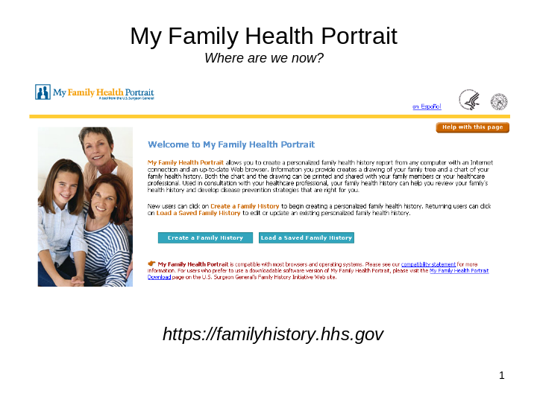

Slide 2

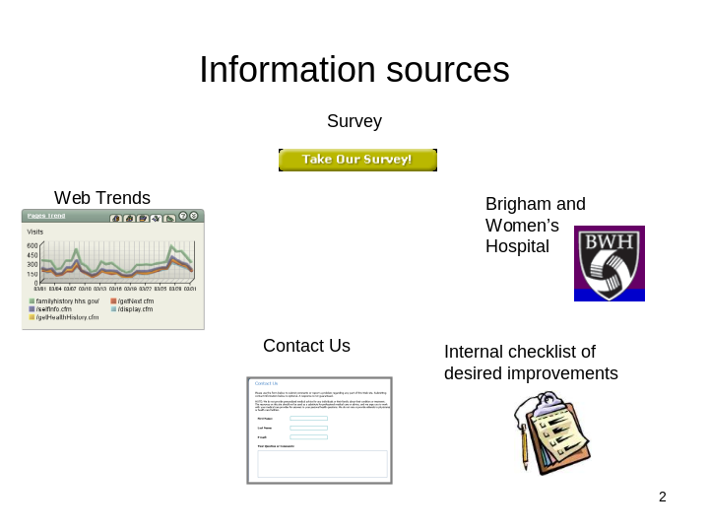

Slide 3

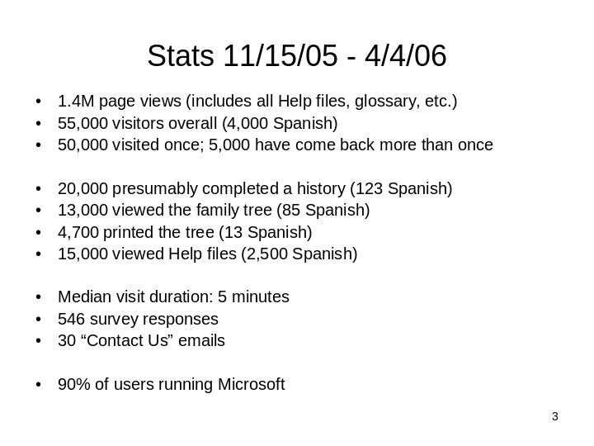
Slide 4

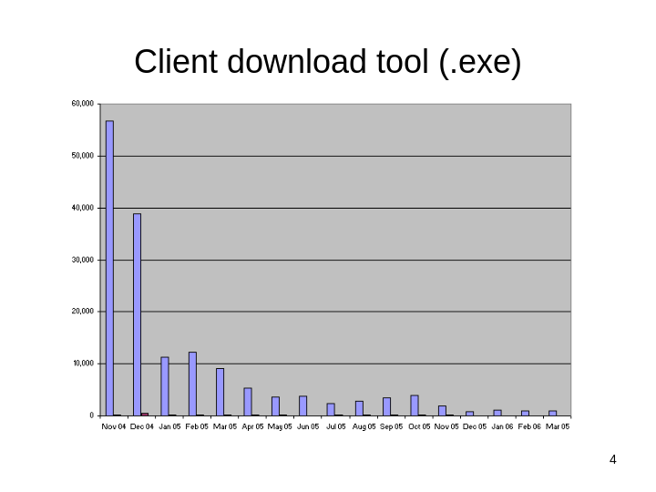

Slide 5

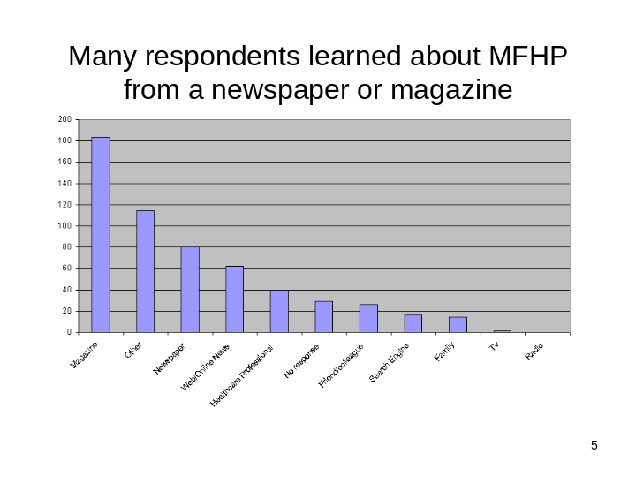

Slide 6

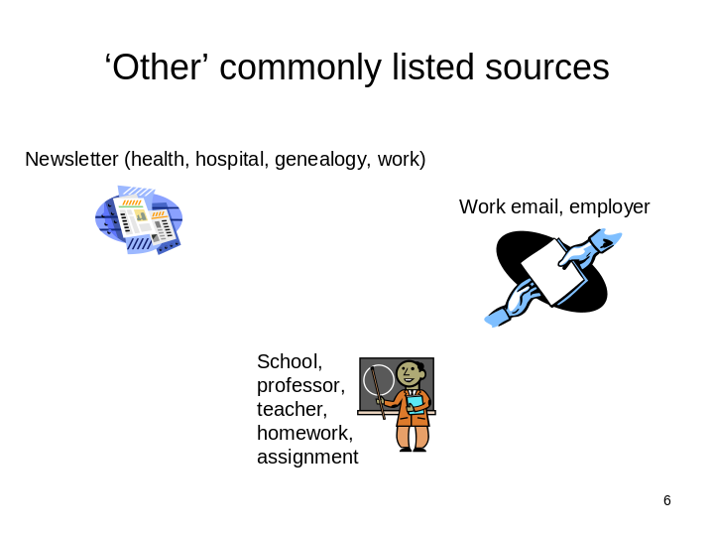

Slide 7

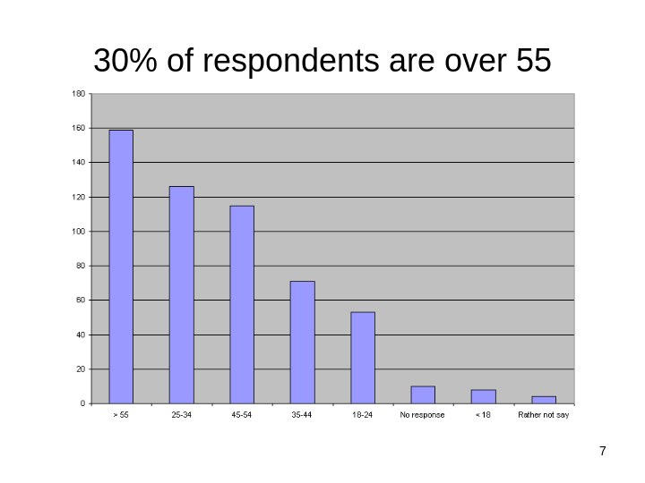

Slide 8

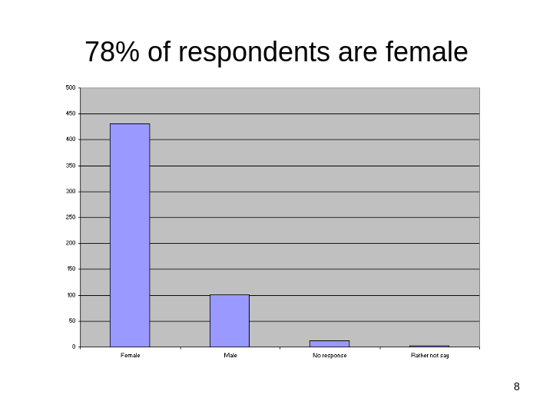

Slide 9

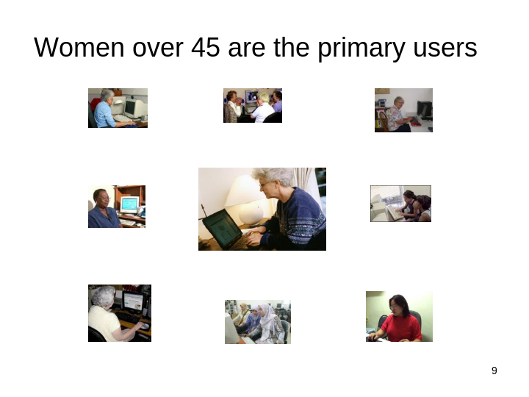

lide 10

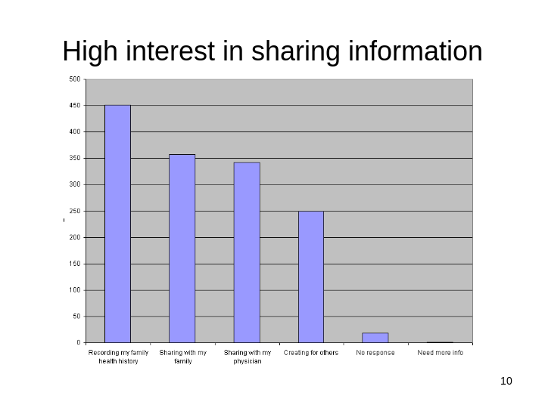

Slide 11

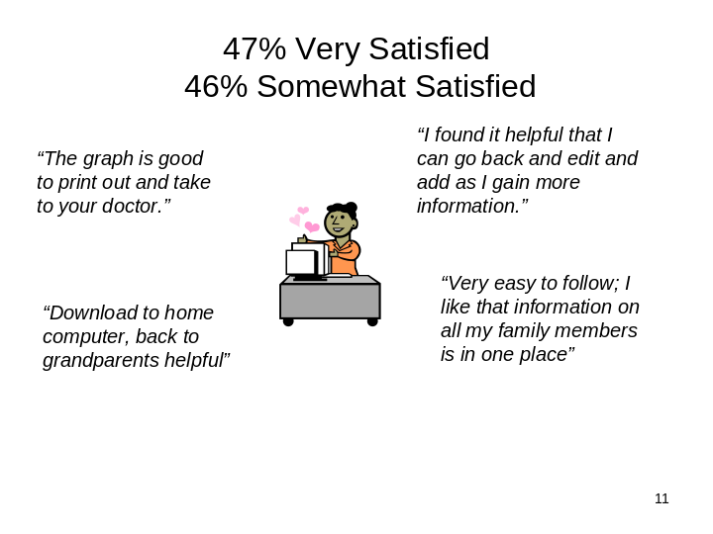

Slide 12

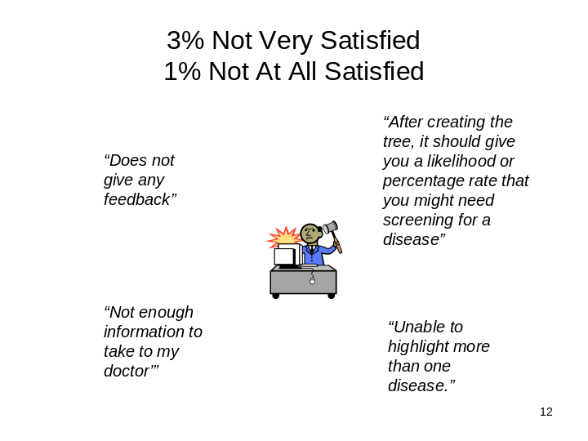

Slide 13

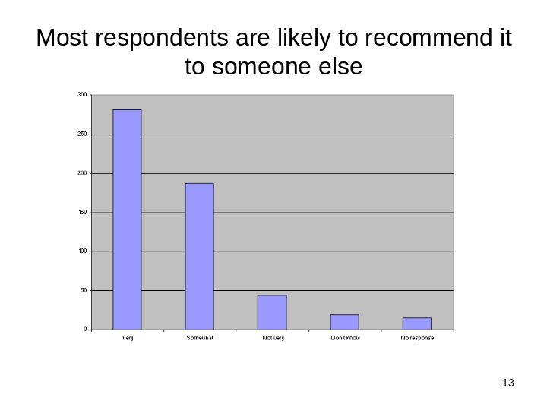

Slide 14

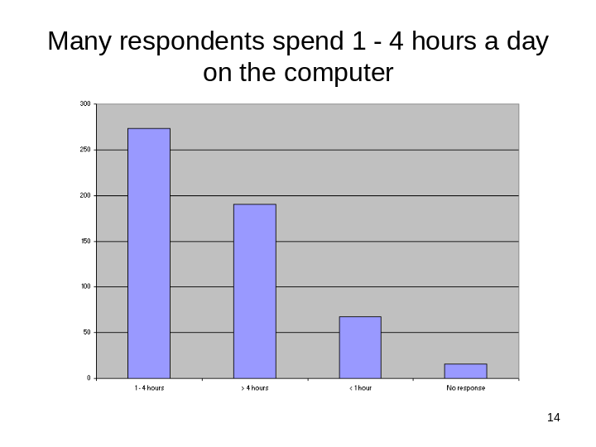

Slide 15

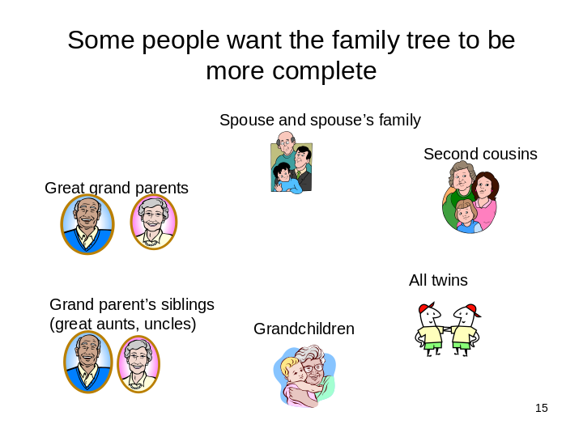

Slide 16

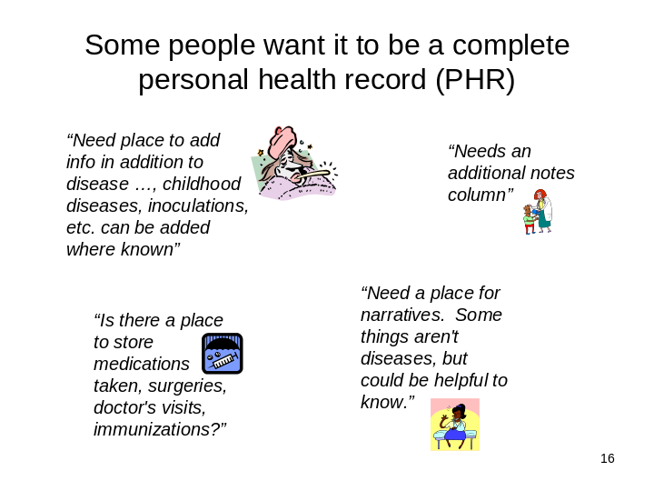

Slide 17

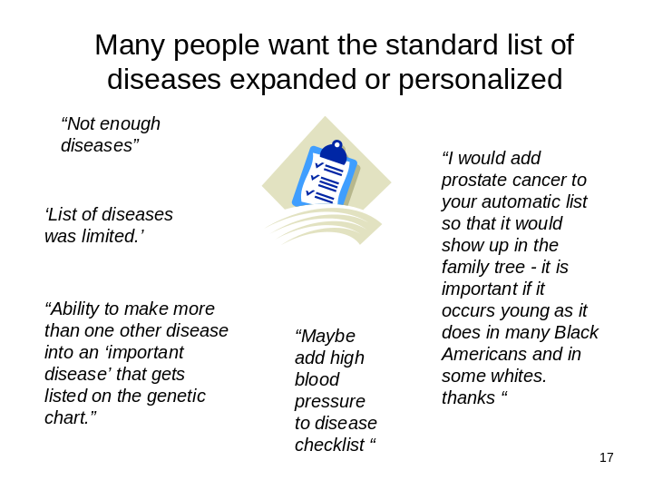

Slide 18

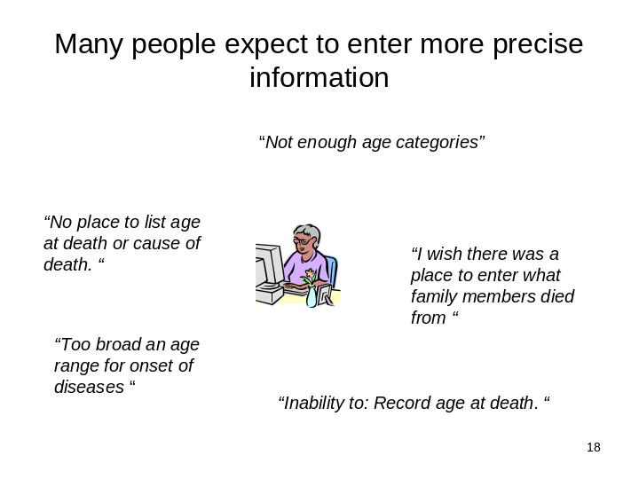

Slide 19

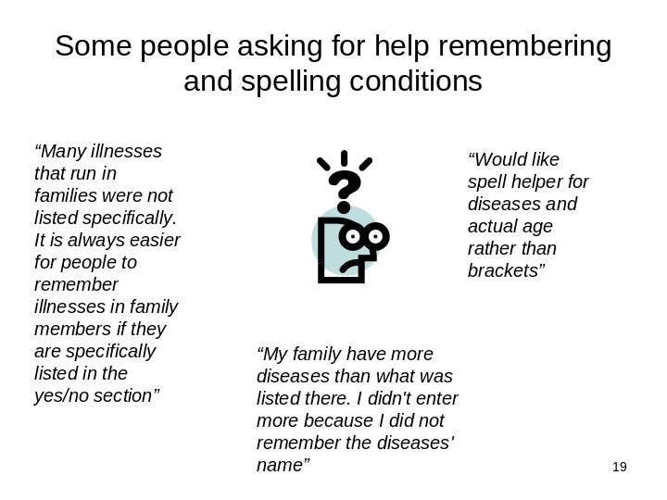

Slide 20

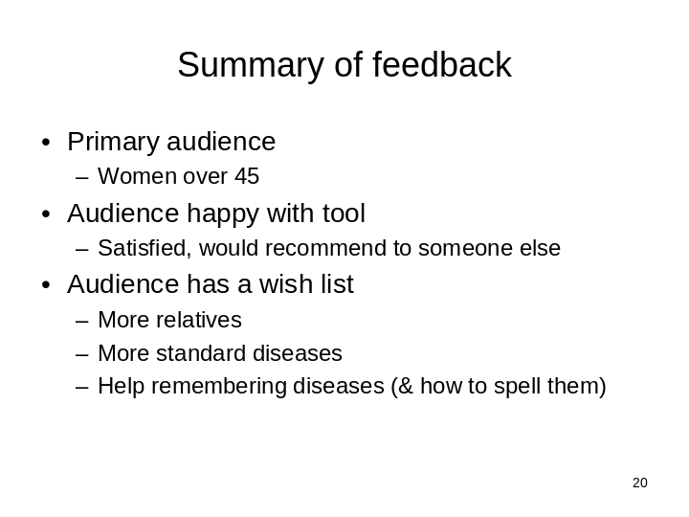

Slide 21



Slide 22

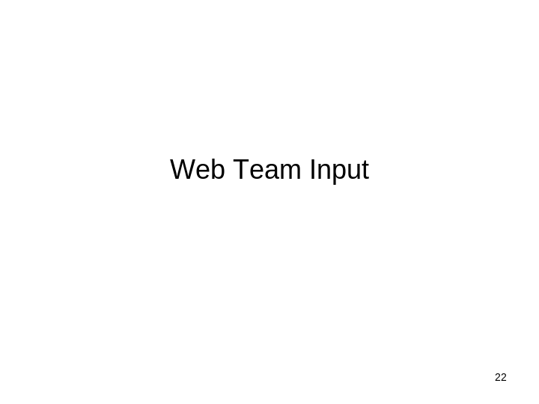

Slide 23

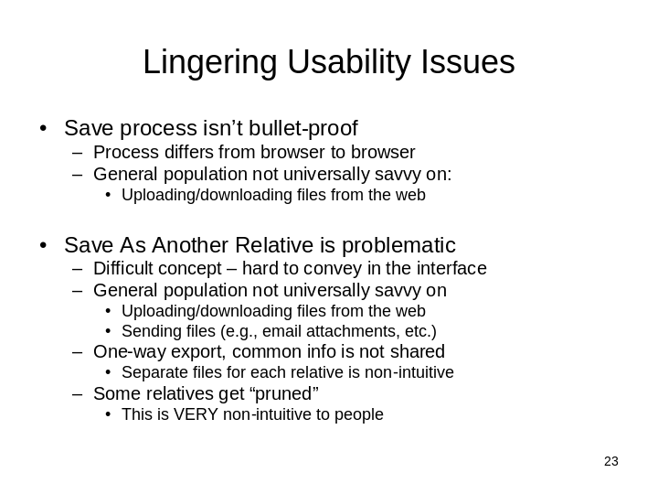

Slide 24

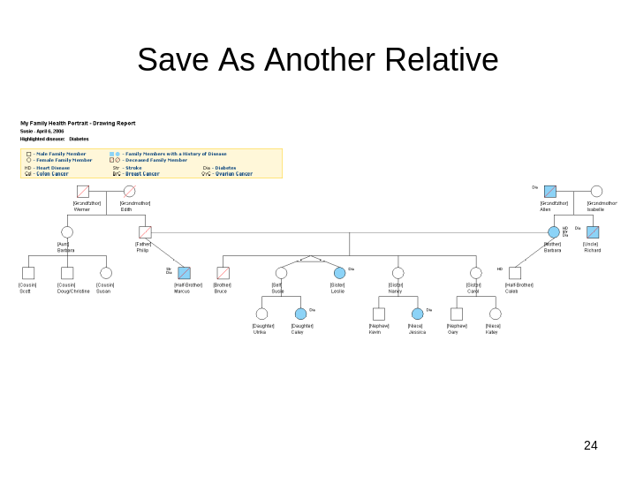

Slide 25

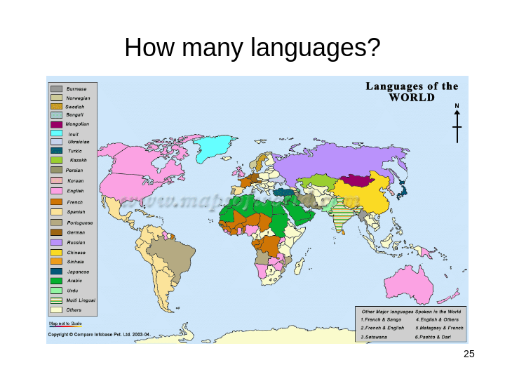

Slide 26

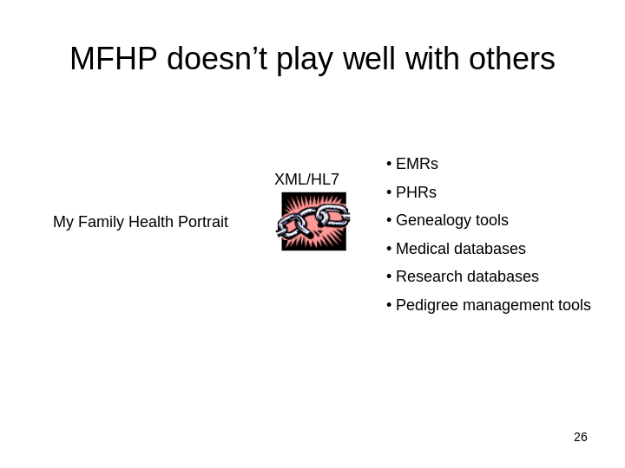

Slide 27

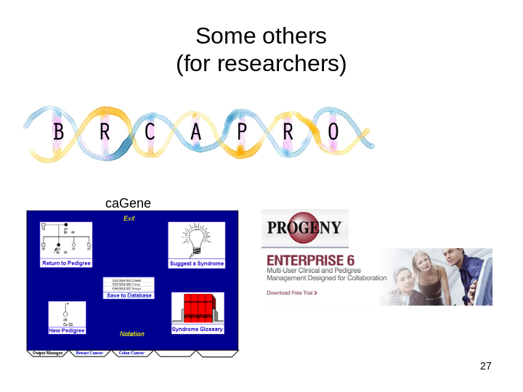

Slide 28

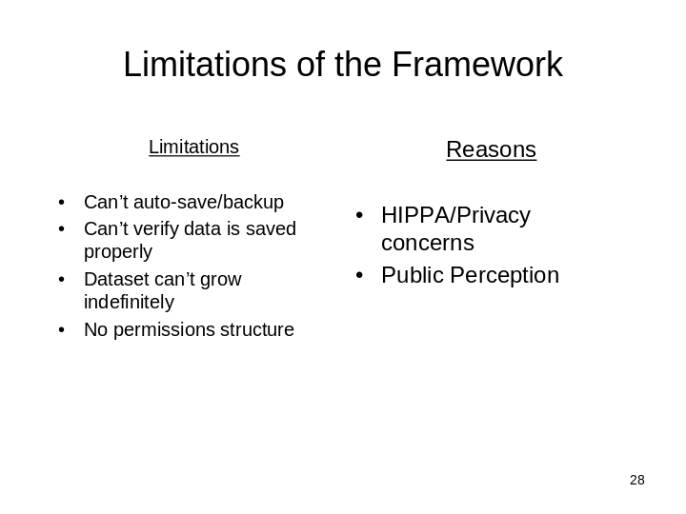

Slide 29

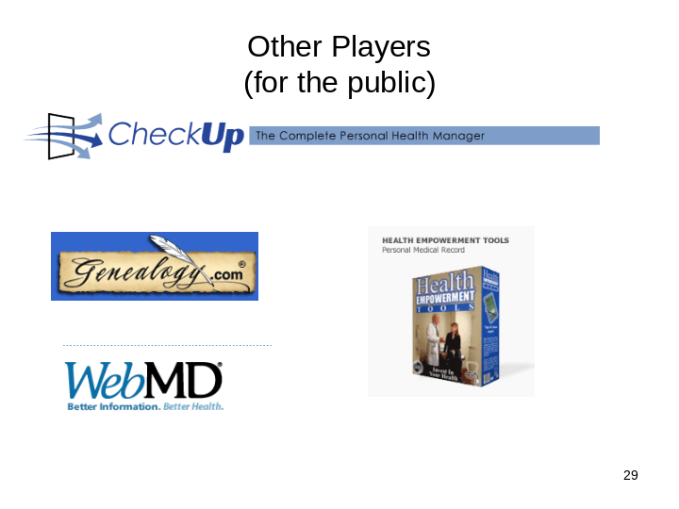

Slide 30

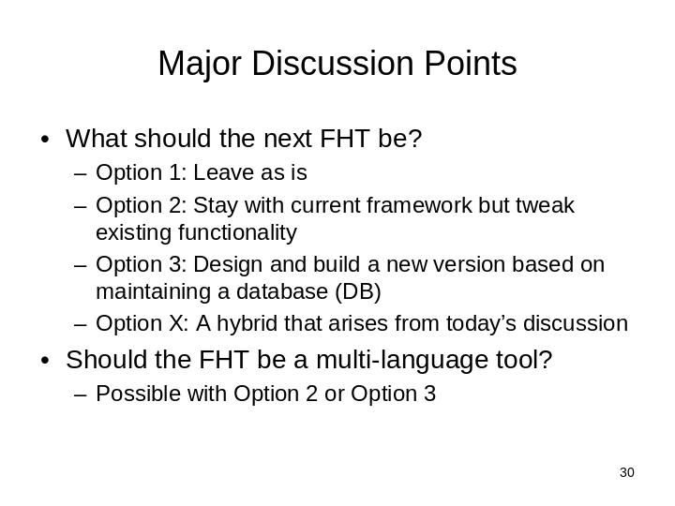

Slide 31

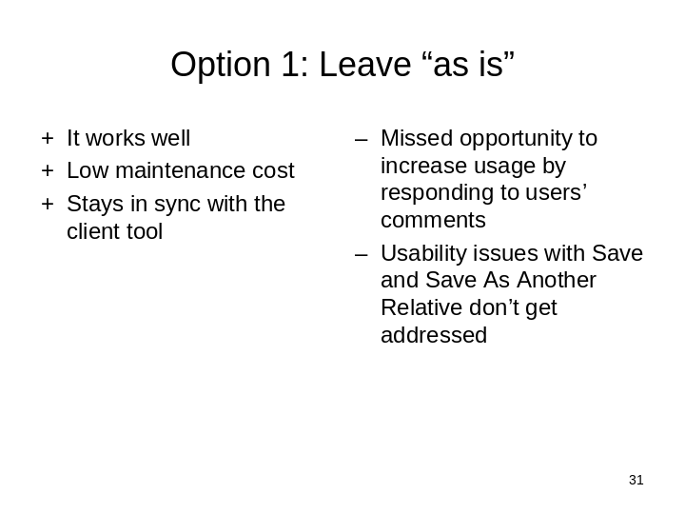

Slide 32

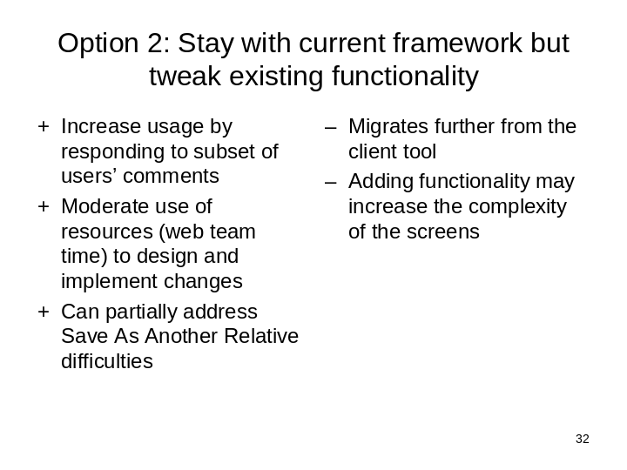

Slide 33

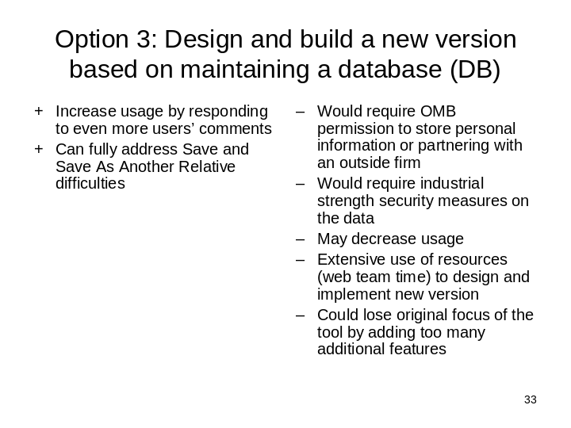

Slide 34

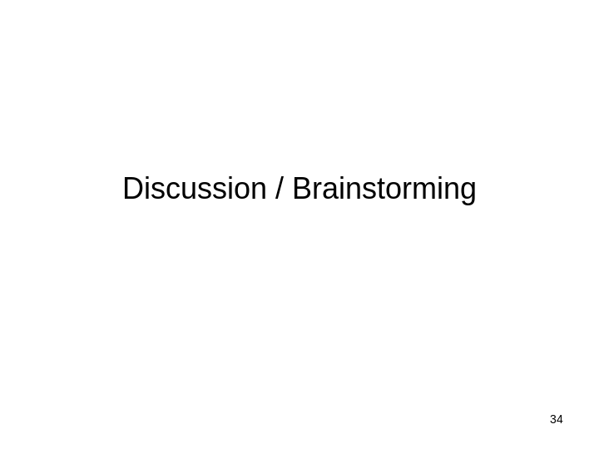

Support Material for Discussion on Future MFHP Functionality
The final slide of the presentation on the current state of MFHP on 4/6/2006 outlined a decision that needed to be discussed by the group about the direction to take for the next 12 months.
Option 1: Leave as is (this was not listed in the tables below because it didn’t require additional supporting information).
Option 2: Stay within the existing framework – which would limit what additional functionality could be done but left the responsibility of storing and securing the users’ personal information in the users’ hands.
Option 3: Move to a database solution - which would allow for a major expansion of functionality but would require a login and that the system store users’ data for them.
The two tables below were supplied to meeting attendees to provide background for the discussion that ensued once the presentation was completed.

Option 2 (Stay with current framework but tweak existing functionality)
Possibilities
Functionality | Pro | Con
Add to standard list of diseases | - Common request  - Keeps standard list but allows people to personalize a bit | - Muddies the reason for the standard list  - Migrates further from the client tool  - People may add genetically-non-determinant diseases  - Screens may become more complex
Support for remembering (and spelling!) diseases  (David may have a simple google-supported solution) | - Fairly common request | - Could add complexity to the screens
Add fields for recording cause and age at death | - Common request | - Are there reasons why the FHT was originally designed not to include this info?
Highlight multiple diseases  (will need to think about impact on Drawing and Chart Reports) | - Fairly common request | - How? (impacts Drawing)
Add video tutorials on the Save and Save As Another Relative processes  (see sheet on video possibilities) | - Videos may be more effective than text instructions | - Watching videos may be too time consuming  - Must make enough to cover most common browser/OS combinations  - Must be 508-compliant
Some export capabilities  Standards-compliant (XML/HL7) file that can be read by other applications such as EMRs, PHRs, etc. | - Allows MFHP to retain original focus on family health history while still supporting other ways of maintaining medical information  - May increase usage | - Requires more savvy from the end-user to know how to export from MFHP and import into another tool such as a PHR  - Muddies focus of the tool  - Technical ramifications
Address (some) Save As Another Relative issues by allowing users to change focus before saving so they can see the rotation first | - May help more people understand the Save As functionality | - Won’t address all of the difficulties

Option 3 (move to DB)
Possibilities
Functionality | Pro | Con
Save to a database | - Can use simpler and less error prone save process  - Fewer users would lose their personal information | - May lose users due to distrust of government or unwillingness to store potentially sensitive personal info “on the web”.
Support for more relatives  Related to Address Save As Another Relative issues below. | - Common request  - May increase usage | - Not intended as complete genealogical tool  - Drawing Report could become unmanageable with an infinitely large family tree (either too small if constrained onto a single page or split across multiple pages)  - Chart and Drawing Reports could become less useful because there will non-relevant relatives in it
Address Save As Another Relative issues  Related to Support for more relatives above.  Could become “Print Drawing report for my mother” instead of “Save As my mother” | - More intuitive to store a family tree instead of individual files for each family member  - Easier to update common family members because all in one place  - Won’t prune “irrelevant” family members when changing focus | - Muddies the purpose of the tool – becomes more like a general genealogical tool  - Could add complexity to the screens
Even more export capabilities  Standards-compliant (XML/HL7) file that can be read by other applications such as EMRs, PHRs, etc. | - Allows MFHP to retain original focus on family health history while still supporting other ways of maintaining medical information  - May increase usage | - Requires more savvy from the end-user to know how to export from MFHP and import into another tool such as a PHR  - Muddies focus of the tool  - Technical ramifications
Additional PHR fields  Doctor’s visits, prescriptions, surgeries, hospitalizations, pregnancies, operations, immunizations, lab work, allergies, blood types, adverse effects of medications, etc | - Common request  - May increase usage | - Adds complexity  - Muddies focus of the tool  - Technical ramifications

Support Material for Discussion on Incorporating Video
The information below was supplied to the group as support material following the presentation.
- What software programs do we use to capture video of the tool?
- MatchWare ScreenCorder?
- Camtasia?
- Other professional software programs we know about?
- What format should we use?
- There was discussion about having the video formats in Flash, since flash can work with all browsers on most operating systems. Other options may include QuickTime or Real Video.
- Videos would have to be made in a format that can be easily accessed over low-bandwidth connections.
- Should we have video with interactivity, where people can navigate within the video at their own pace?
- Where to implement video?
- Include video on each page or only a few pages?
- For consistency, if video could be included on all pages, as a form of help. The question is whether it is necessary to go that far?
- If video was included on few pages, the most logical pages would be Save To, Save As, Health History pages- pages where the processes are not “bulletproof”.
Pro (if video is on all pages) |  | Con
Users who have trouble comprehending the meaning of text can see video to help them in each step of creating a Family Health History |  | Labor intensive to develop, maintain. This becomes more evident if we change the functionality dramatically and/or if the look and feel is changed.
Pro (If video is on a few select pages) | Con
- Less labor intensive than the previous option- only targeted to few processes that aren’t so intuitive (Save To, Save As, etc..) | - Can be a disadvantage to challenged users who need extreme handholding every step of the way towards creating a Family Health History.

- How long videos should be?
Pro (If videos are shorter than 1 min) | Con
- Easy for users to follow. | - Might not be as comprehensive. May leave users still asking questions.
Pro (If videos are longer than 1 min) | Con
- More comprehensive. | - May be a disadvantage to users with low attention spans.
- Less than 30 seconds?
- 30 seconds to 1 minute?
- More than 1 minute?
- How do we make videos 508-compliant?
We’d have to accommodate users who are vision-impaired as well as those who are hearing-impaired.
To address the vision-impaired, the video would need audio/voiceovers?
To address the hearing-impaired, the video would need to have captions?
And if we use captions someone would have to write the content (most likely Mukul and have it approved by the general consensus). The captions would have to be coordinated very well with the frames in the video.
- Do we make equivalent videos for the Spanish version of MFHP?
Will need to rely on the translators or find a person to speak Spanish for the voiceovers. Too much work?

Section 508 compliance refers to the Section 508 of the Rehabilitation Act (29 U.S.C. 794d) which states that federal agencies must give disabled employees and members of the public access to information that is comparable to the access available to others.
A screen reader is an application that can read a web page and allow a person to navigate via the keyboard rather than the mouse. This is the most common method used by vision-impaired people to access the internet.
The client tool collected information on six diseases (heart disease, stroke, diabetes, colon cancer, ovarian cancer, breast cancer) for every family member and gave only two text-boxes for people to enter additional diseases for a family member.
Government servers are prohibited from storing personally identifying information on web visitors.
Survey questions and the data that was collected are listed in Appendix E.
Brigham and Women’s Hospital received funding from NHGRI to investigate how health care providers react to and use the family health history information provided by MFHP.
For copies of the raw data set in an excel file contact: Larry Thompson (Chief, Communications and Public Liaison Branch) Phone: (301) 594-0954 E-mail: thompsl@mail.nih.gov
For copies of the raw data set in an excel file contact: Larry Thompson (Chief, Communications and Public Liaison Branch) Phone: (301) 594-0954 E-mail: thompsl@mail.nih.gov

